Volunteering Development Officer
Service: | Human Resources
Responsible To: | Head of Fundraising
Salary: | £27,013 – £30,457

Job Purpose
There are many areas in which volunteers can add significant value and capacity to the work of the Foundation – Working with children in our schools, tending to garden areas, driving, supporting adult service users on activities and in helping with fundraising and events.

The Volunteering Development Officer will lead in all areas that will underpin a high-quality volunteering function for the Foundation. This will include, coordination of actual volunteering activity, the recruitment of volunteers, working with the corporate fundraiser, the marketing team the employment experience team, HR, our Estates team and external agencies where appropriate.

As part of the role you will curate new and exciting skilled and unskilled volunteering opportunities. Review our policies and procedures, undertake risk assessments, attend sites to welcome and host corporate volunteers and undertake tours of sites as appropriate.

Main Duties
- To respond to all volunteering queries and provide volunteering information and advice across the Foundation.

- To review and develop where necesaary appropriate Strategy, Policies and Procedures, Risk Assessments and Role Descriptions for volunteering opportunities throughout the Foundation.

- To work with the communications team to implement a volunteering marketing plan through appropriate social media platforms, advertising and events.

- To work closely with colleagues to identify the potential for volunteers and promote associated advantages to service users and staff teams within their Departments. Drive the processes to then deliver a professional, high-quality volunteering service.

- To lead on volunteer recruitment through liaison with the Marketing Team ensuring there is a year-round consistent and attractive campaign that draws volunteers to the Foundation.

- To manage volunteer application process, including contact and engagement, shortlisting, interviewing, and conducting relevant safeguarding checks.

- To establish and maintain the DBS checking process and associated record keeping for all volunteers in close liaison with HR colleagues.

- To provide monthly reporting information on volunteering to the Head of Fundraising.

- To network and liaise with local companies to promote the benefits of volunteering and corporate social responsibility days. Arrange and manage non-regular, ad-hoc volunteering days.

- To link volunteers to known projects, tasks and opportunities within the Foundation – ensuring that the related staff team member(s) has thorough plans in place to receive and manage those volunteers. This will include meaningful roles, necessary equipment, appropriate planning for the day, safety briefings and support.

- To coordinate any training necessary for volunteers. This will in time include an annual programme of events that best equip the volunteers with knowledge and that also grows their confidence.

- To support and oversee any concerns or complaints involving Volunteers.

Organisational Standards
The Percy Hedley Foundation operates in a demanding and often changing environment. Members of staff must be flexible, adaptable, willing to face up to changing circumstances and new opportunities. The following list of duties and responsibilities must therefore be taken as a guide and is not to be comprehensive.

Professional Duties
- Participate in the review of the Foundations Policies, Procedures and Processes
- Participate in arrangements for the performance development review process
- Participate in arrangements for further training and professional development
- Keep up to date with changes or developments within your professional area
- Fully participate in the induction and training programme provided by the Percy Hedley Foundation
- Contribute to the professional development of other staff, including the induction of new staff.

Equality and Diversity
- Promote equality of access to education, training, and employment opportunities for disabled people, and advocate a positive attitude
- Recognise that disabled people are individuals who have specific needs
- Employ support strategies that will empower disabled people
- Show awareness of knowledge and display non-discriminatory behaviours at all times in relation to culture, race, ethnicity, disability, gender, sexuality, and age
- Recognise the importance of inclusion by using appropriate means of communication at all times
- Be flexible, trying to meet the changing needs of both disabled people and environment.

Discipline, Health and Safety
- Adhere to and promote Percy Hedley Foundation Health, Safety and Welfare policy at all times
- Purchase equipment from a recognised source
- Report all incidents and accidents to Health and Safety Officer
- Maintain a high standard of record keeping in line with Percy Hedley Foundation policies and procedures.

Safeguarding
- Safeguarding is everyone’s responsibility.
- Percy Hedley Foundation have adopted recruitment and selection procedures, and other Human Resource Management processes, that help deter, reject, or identify people who might abuse vulnerable children/adults, or are otherwise unsuited to work with them.
- The Trustees/Governing Body are committed to promoting the welfare of children and young people/adults and staff are expected to ensure that the highest priority is given to following guidance and regulations to safeguard those in our care.

Confidentiality
- Respect confidentiality. All personal information about people using the foundations services to which you have access should be treated as confidential. Information about the people’s needs, progress and assessment should only be shared with the team to aid support
- Remain objective and do not favour any gender, language or culture and comply with the Percy Hedley Foundation policy.

About Us

We are an ambitious, entrepreneurial, and innovative charitable business working in a person-centred way to meet the needs of people with disabilities and their families. We provide a range of high-quality services and seek out opportunities to inspire and support people with disabilities to achieve their ambitions. We believe that working together as one Foundation we achieve more than individual services would achieve alone. Our influence will be regional, national & international.

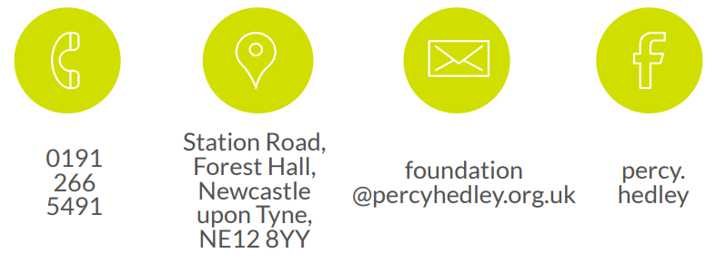
We are committed to safeguarding and promoting the welfare of children, young people, and vulnerable adults. Applicants should be aware that the post will only be offered to successful candidates subject to an Enhanced DBS check as well as other employment clearances.

