# Senior Administrator – Data Protection and Records Management

|  |  |
| --- | --- |
| Service: | Central Services |
| Responsible To: | Records Manager & DPO |
| Salary: | Pts 7 – 11 (£25,281 - £27,013) |

|  |
| --- |
| Job Purpose |
| This role is to provide administrative support to the Foundation’s Records Manager and DPO/ Corporate Quality Manager supporting work to ensure appropriate arrangements in the areas of data protection and records management.  The role will also provide cover in the areas of Health and Safety and Governance as and when required(with appropriate training) |
|  |
| Main Duties |
| **Data Protection**   * Assist in responding to data subject access and information requests to meet regulatory time scales specifically engaging with services to obtain required documentation and undertaking redaction. * Supporting the DPO in ensuring that all Data Protection policies remain up to date * Supporting the DPO in ensuring data breach reports are prepared, incidents are logged using care compliance and closure of actions is timely * Supporting the DPO with specific tasks related to the data protection annual work plan. This may include:   + maintaining DPST accreditation,   + preparation of Records of processing Activities (ROPAs),   + Privacy statements,   + Information Asset Registers(IARs),   + completing Data Protection Information Assessments(DPIAs). * Liaising with Contractors and Suppliers on data protection related matters. * Acting as a point of contact for advice and guidance regarding data and information management for all business areas * Working with the Governance team to compile monthly reporting data * Supporting the DPO in preparing and disseminating regular updates to staff * Supporting induction and other training activities for staff in relation to organisational systems, processes and procedures   **Records Management**   * Support the Records Manager with all arrangements for records management * Provide support and guidance to local services regarding disposal of records in line with the data retention policy * Support the Records Manager with archiving activities * Work with FM team in ensuring disposal arrangements through a 3rd party are working in line with contractual arrangements   **Other Duties**   * Provide administrative support to cover other administrators (ie Vatix, Care Compliance etc) as and when necessary for Health and Safety and Governance teams * Provide ad hoc support in preparing and distributing papers and reports ahead of meetings, forums and events * Attend meetings to act as minute taker * Attend external training events workshops as agreed * Monitoring Foundation e-mail boxes * Monitoring of various mailboxes * Managing diaries / phone messages |

# Person Specification

|  |
| --- |
| Essential Criteria |
| Skills and Knowledge   * Excellent people skills to develop strong internal networks and relationships with the Foundation and service areas * An experienced user of IT and well developed skills using standard MS Office applications particularly Word, Excel and Powerpoint * Excellent communication skills, both verbal and written. Demonstrable ability to communicate issues, with particular regard to written reports and register management, clearly to operational staff at all levels * Ability to prioritise workload and work under pressure to meet reporting deadlines   Qualifications and Training   * Business qualifications or appropriate and relevant degree level certificates and significant   Experience   * Relevant work experience in areas of data protection and records management Personal Qualities |

# Organisational Standards

The Percy Hedley Foundation operates in a demanding and often changing environment. Members of staff must be flexible, adaptable, willing to face up to changing circumstances and new opportunities. The following list of duties and responsibilities must therefore be taken as a guide and is not to be comprehensive.

|  |
| --- |
| Professional Duties |
| * Participate in the review of the Foundations Policies, Procedures and Processes * Participate in arrangements for the performance development review process * Participate in arrangements for further training and professional development * Keep up to date with changes or developments within your professional area * Fully participate in the induction and training programme provided by the Percy Hedley Foundation * Contribute to the professional development of other staff, including the induction of new staff. |
|  |
| Equality and Diversity |
| * Promote equality of access to education, training, and employment opportunities for disabled people, and advocate a positive attitude * Recognise that disabled people are individuals who have specific needs * Employ support strategies that will empower disabled people * Show awareness of knowledge and display non-discriminatory behaviours at all times in relation to culture, race, ethnicity, disability, gender, sexuality, and age * Recognise the importance of inclusion by using appropriate means of communication at all times * Be flexible, trying to meet the changing needs of both disabled people and environment. |
|  |
| Discipline, Health and Safety |
| * Adhere to and promote Percy Hedley Foundation Health, Safety and Welfare policy at all times * Purchase equipment from a recognised source * Report all incidents and accidents to Health and Safety Officer * Maintain a high standard of record keeping in line with Percy Hedley Foundation policies and procedures. |
|  |
| Safeguarding |
| * Safeguarding is everyone’s responsibility. * Percy Hedley Foundation have adopted recruitment and selection procedures, and other Human Resource Management processes, that help deter, reject, or identify people who might abuse vulnerable children/adults, or are otherwise unsuited to work with them. * The Trustees/Governing Body are committed to promoting the welfare of children and young people/adults and staff are expected to ensure that the highest priority is given to following guidance and regulations to safeguard those in our care. |
|  |
| Confidentiality |
| * Respect confidentiality. All personal information about people using the foundations services to which you have access should be treated as confidential. Information about the people’s needs, progress and assessment should only be shared with the team to aid support * Remain objective and do not favour any gender, language or culture and comply with the Percy Hedley Foundation policy. |

# About Us

### We are an ambitious, entrepreneurial, and innovative charitable business working in a person-centred way to meet the needs of people with disabilities and their families. We provide a range of high-quality services and seek out opportunities to inspire and support people with disabilities to achieve their ambitions. We believe that working together as one Foundation we achieve more than individual services would achieve alone. Our influence will be regional, national & international.

### 

We are committed to safeguarding and promoting the welfare of children, young people and vulnerable adults. Applicants should be aware that the post will only be offered to successful candidates subject to an Enhanced DBS check as well as other employment clearances.

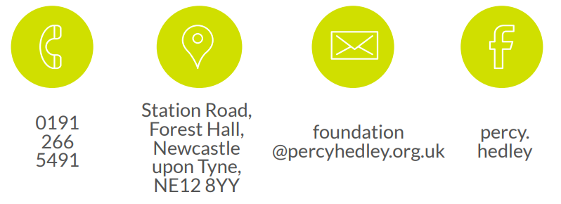

0191 238 1301

Hampeth Lodge

Station Road

Forest Hall

NE12 8YY

recruitment@

percyhedley.org.uk

<https://www.facebook.com/percy.hedley>