Nurse
Service: | Hedleys College
Responsible To: | College Lead Therapist / Foundation Lead Nurse
Salary: | Phase 2

Job Purpose
To provide assessment, planning and implementation of health care for young adults attending Hedleys College. To be responsible for supporting student’s medical needs, both physically and emotionally. To work and collaborate with other professionals to ensure there is seamless support to our students and support network. To promote student’s health and wellbeing through the development of nurse led sessions in conjunction with the wider therapy and educational team.

Main Duties
- To be responsible for supporting the medical needs of college students, both physically and emotionally. This will always include assisting in the safety and medical welfare of the students.
- To involve parents/carers and young people and encourage them to make informed choices concerning their health and general well-being.
- To communicate effectively with the young person and their carers to understand their condition. To give sensitive/emotive information around diagnosis and/or outcomes. Barriers to effective communication will regularly be experienced.
- To plan, implement and evaluate nursing interventions and health promotional developments within college.
- To work without direct supervision and be responsible for the management of own workload.
- To make referrals or liaise with appropriate hospital specialties/agencies.
- To support staff in providing up to date and skilled care which will include the administration of medication, care of tracheostomies, gastrostomies and the passing of catheters, administration of oxygen as examples.
- To support with the development of policies and procedures for medication including MAR charts and convey this information to staff.
- To develop and follow agreed clinical policies and procedures.
- To be able to work effectively within the college setting.
- Support with relevant auditing activities within services.
- To attend annual review meetings as required, discharge planning meetings, multi-disciplinary meetings and case conferences.
- To be part of the assessment process for new students.
- To be responsible for delivering or arranging training of staff, in certain areas of care, e.g. administration of medication, naso-gastric feeds, gastrostomy feeds, respiratory support including suctioning and tracheostomies.
- To identify ongoing training needs and agreed competency levels for staff.
- To participate in the training programmes creating an appropriate learning environment to meet educational and regulatory standards.
- To maintain accurate, contemporaneous professional records in accordance with NMC guidelines and Record Keeping policy.
- To ensure medical care plans are updated and shared with relevant services, as appropriate.
- To ensure all Safeguarding incidents are reported in line with Foundation policies and procedures.
- To keep up to date with developments within your field, disseminate information, and ensure that practice is based on best available evidence.
- To participate in the evaluation of the services identifying any future changes and developments needed.

Person Specification

Essential Criteria
Experience, Skills, and Knowledge
- A sound knowledge of common medical conditions including diabetes and asthma, as well as disorders commonly associated with learning disabilities such as cerebral palsy and autism
- A sound knowledge of community-based management of tracheostomies, gastrostomies, and seizure management
- Experience of working with individuals with learning disabilities
- An understanding of national initiatives (i.e. LeDer, STOMP, Your Welcome)
- Moving and Handling skills
- Basic keyboard skills, experience writing care plans and ability to document accurately
- Ability to communicate and collaborate with colleagues
- Ability to work with external agencies
- Be involved in making shared decisions
- Organise, facilitate and develop a strong working practice

Qualifications and Training
- Qualified and registered nurse.
- Evidence of safeguarding training.

Personal Qualities
- A positive and can-do attitude.
- High level communication and interpersonal skills.
- Ability to work easily and flexibly in a team.
- Commitment to personal responsibility and corporate obligation – One Foundation and decision making for the greater good.
- Integrity and alignment to the Foundation’s core values.
- An ability to represent the Percy Hedley Foundation externally and take on an ambassadorial role where appropriate.
- A solution focused proactive approach to resolving issues.
- Ability to effectively manage own time and resources.

Organisational Standards
The Percy Hedley Foundation operates in a demanding and often changing environment. Members of staff must be flexible, adaptable, willing to face up to changing circumstances and new opportunities. The following list of duties and responsibilities must therefore be taken as a guide and is not to be comprehensive.

Professional Duties
- Participate in the review of the Foundations Policies, Procedures and Processes
- Participate in arrangements for the performance development review process
- Participate in arrangements for further training and professional development
- Keep up to date with changes or developments within your professional area
- Fully participate in the induction and training programme provided by the Percy Hedley Foundation
- Contribute to the professional development of other staff, including the induction of new staff.

Equality and Diversity
- Promote equality of access to education, training, and employment opportunities for disabled people, and advocate a positive attitude
- Recognise that disabled people are individuals who have specific needs
- Employ support strategies that will empower disabled people
- Show awareness of knowledge and display non-discriminatory behaviours at all times in relation to culture, race, ethnicity, disability, gender, sexuality, and age
- Recognise the importance of inclusion by using appropriate means of communication at all times
- Be flexible, trying to meet the changing needs of both disabled people and environment.

Discipline, Health and Safety
- Adhere to and promote Percy Hedley Foundation Health, Safety and Welfare policy at all times
- Purchase equipment from a recognised source
- Report all incidents and accidents to Health and Safety Officer
- Maintain a high standard of record keeping in line with Percy Hedley Foundation policies and procedures.

Safeguarding
- Safeguarding is everyone’s responsibility.
- Percy Hedley Foundation have adopted recruitment and selection procedures, and other Human Resource Management processes, that help deter, reject, or identify people who might abuse vulnerable children/adults, or are otherwise unsuited to work with them.
- The Trustees/Governing Body are committed to promoting the welfare of children and young people/adults and staff are expected to ensure that the highest priority is given to following guidance and regulations to safeguard those in our care.

Confidentiality
- Respect confidentiality. All personal information about people using the foundations services to which you have access should be treated as confidential. Information about the people’s needs, progress and assessment should only be shared with the team to aid support
- Remain objective and do not favour any gender, language or culture and comply with the Percy Hedley Foundation policy.

About Us

We are an ambitious, entrepreneurial, and innovative charitable business working in a person-centred way to meet the needs of people with disabilities and their families. We provide a range of high-quality services and seek out opportunities to inspire and support people with disabilities to achieve their ambitions. We believe that working together as one Foundation we achieve more than individual services would achieve alone. Our influence will be regional, national & international.

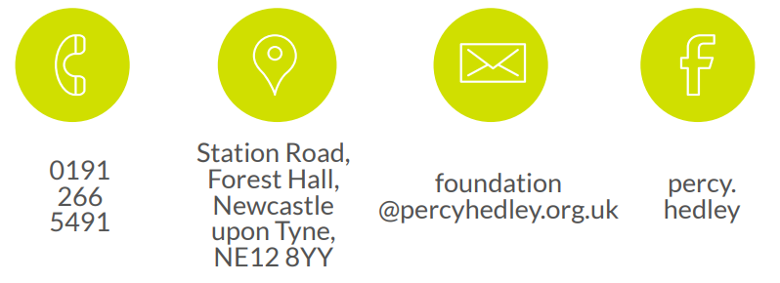
We are committed to safeguarding and promoting the welfare of children, young people, and vulnerable adults. Applicants should be aware that the post will only be offered to successful candidates subject to an Enhanced DBS check as well as other employment clearances.

