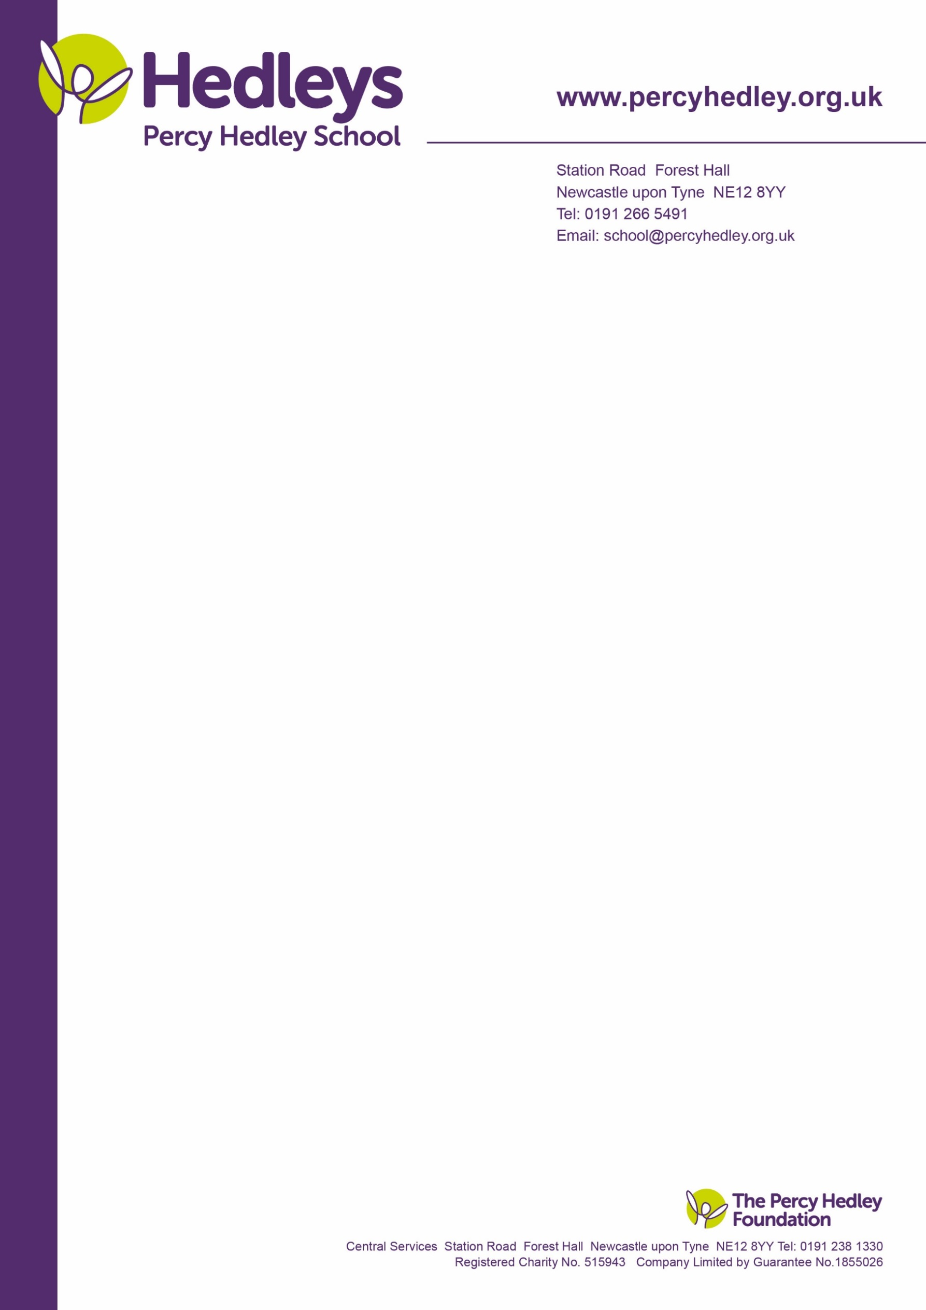

Dear parent/carer,

On Thursday 19th December the Enterprise group are holding a Christmas Fayre. The FoPHS will also have a stall. This is an opportunity for students to develop skills around work related activity.

You will be able to purchase items they have made, support the tombola, raffle and other stalls. There will be refreshments too.

Parents, carers and family members of students in classes from Key Stage 3 and above are invited.

Thanks to all who have donated items for them to sell, raffle etc. If you have raffle tickets, please return as soon as possible to help us with preparation. We are still accepting donations for the tombola and raffle prizes. These can be sent in fao Eileen or Hazel.

Please return the reply slip below. This helps us with an easier sign in process at reception for busy events.

Best wishes,

Andrea Walker.

Department Lead Post 16.

Please cut out and return fao Eileen Robinson by Tuesday 17th December

I will/will not be attending the Christmas Fayre (delete as appropriate)

Names of those attending: _________________________________________________________

_______________________________________________________________________________

My child/young person’s name and class: _____________________________________________

Signed: ____________________________________________________________________

Relationship to student:_________________________________________________________

.

West Lane, Killingworth

Newcastle upon Tyne, NE12 7BH

Tel: 0191 216 1811

Email: school@percyhedley.org.uk

13th December 2024