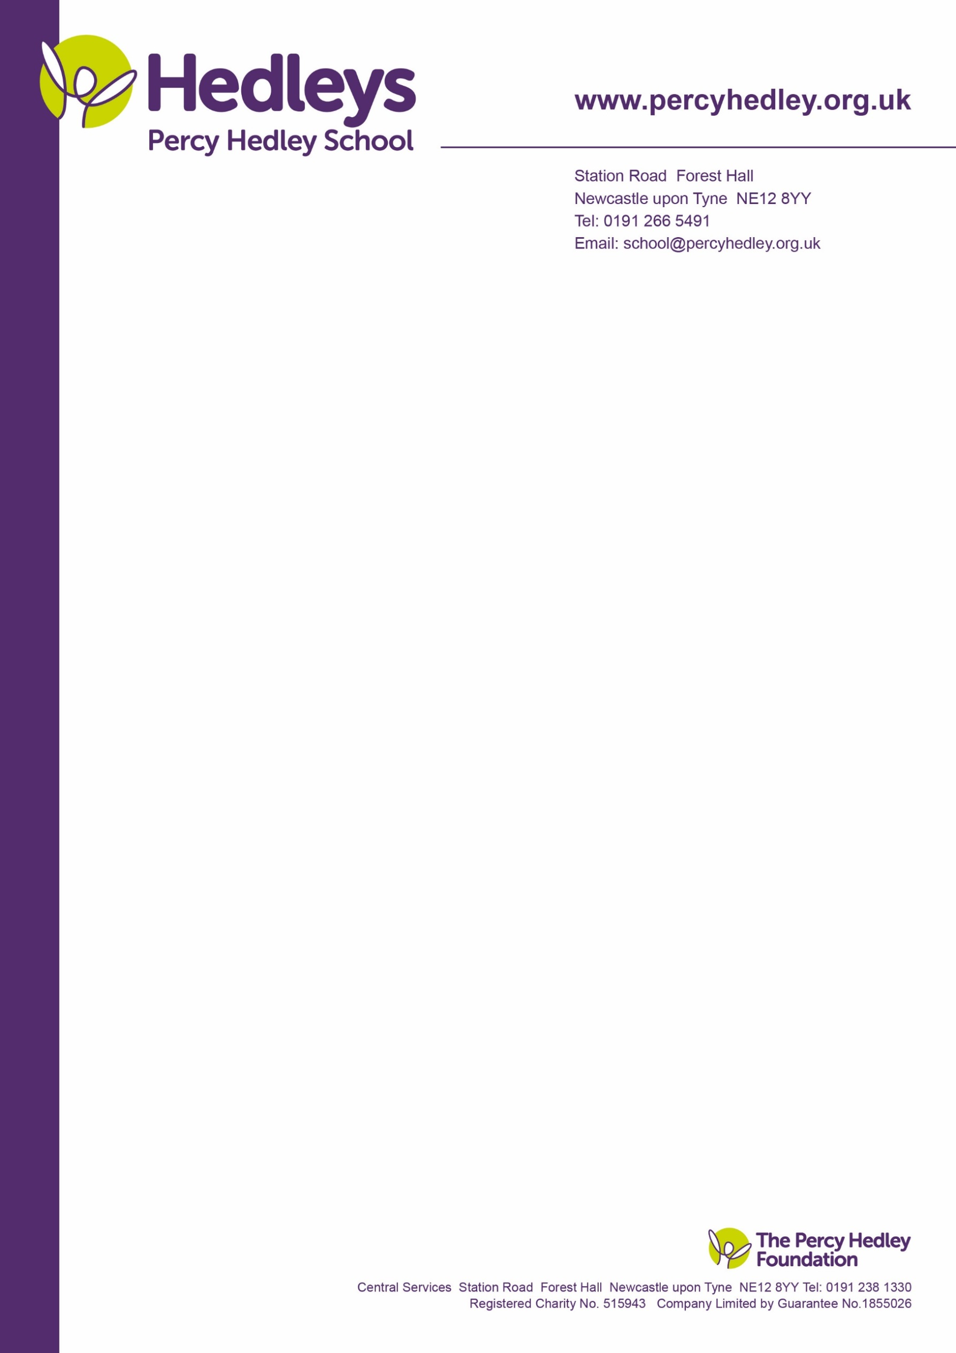
Dear parent/carer,

16 – 19 Bursary Fund.

This letter is important and requires your attention. As we are in the process of planning residential trips for Post 16 next year, we need to know which students are eligible for the bursary.
To qualify your child/young person must be aged 16 or over and under 19 years on 31st August 2024. Discretionary bursary may be paid to those over the age of 19 if the course started before they were 19. This covers our year 14 students.

- Vulnerable Student Bursary: (this refers to the income of the applicant: child/young person)
Is your child/young person in receipt of Income Support or Universal Credit: Yes/No
Is your child/young person a care leaver or currently looked after in care? Yes/No
Is your child/young person a disabled student in receipt of both Disability Living Allowance/Personal Independence Payment AND Universal Credit (limited capacity for work related activity element)? Yes/No

Or (you cannot apply for both)

- Discretionary Student Bursary: (this refers to family income, not including DLA/PIP in students name)
Is your household income below £40,000 per annum? Yes/No

These bursaries are provided by the government (Skills Funding Agency) to cover the additional cost of education from Year 12 onwards and funds spent must be for this purpose only.
School meals will be provided as part of the bursary. Discretionary bursaries are at the discretion of school. Funds are applied for and managed by school.
The link to the government site:
https://www.gov.uk/1619-bursary-fund/eligibility
For further information on eligibility, please check this site.

Please cut out and return the section below no later than Friday 28th June 2024 marked for my
attention (staff, please return to me)
Best wishes,

Eileen Robinson: Family Liaison Officer
Email: e.robinson@percyhedley.org.uk
Telephone: 0191 2161811 ext 3260

Child/young person’s name and class: _____________________________________________

This student is eligible for the Vulnerable Student Bursary: yes/no
This student is eligible for the Discretionary Student Bursary: yes/no
This student is not eligible for a bursary: (please circle if this is the case)
Please return this form to Eileen Robinson no later than Friday 28th June 2024 or email me.

West Lane, Killingworth
Newcastle upon Tyne, NE12 7BH
Tel: 0191 216 1811
Email: school@percyhedley.org.uk
19th June 2024

