Minibus Driver
Service: | Central Services
Responsible To: | Transport Manager
Salary: | Point 5

Job Purpose
To provide transportation of Service Users to and from various locations in accordance with the practices and procedures of the Foundation.

Main Duties
- Transport pupils/students to and from locations, as required. Drivers may also be expected to transport equipment, materials, and other stock and where necessary rearrange the seating of the vehicle.
- Responsibility for the opening and re-securing or vehicle doors.
- Ensure Service User have their seatbelts properly secured, wheelchairs are secured, and seatbelts are worn at all times.
- Ensure the maximum seating capacity of the vehicle is not exceeded at any time.
- Maintain driving, vehicle, and record logs.
- Undertake and document appropriate pre/post vehicle checks and required routine maintenance, reporting defects as appropriate.
- Re-fuel the minibuses as required.
- Clean the vehicle(s), including internal and external washing, ensuring spillages are cleaned up.
- Have knowledge of basic first aid and be able to recognise and take necessary action to deal with a medical emergency on the vehicle.
- Take appropriate steps to obtain assistance or alternative transport in the event of an accident or a vehicle breakdown.
- Ensure prompt reporting of any matters relating to the vehicle, e.g. accidents, difficulties in bad weather and ensure that any associated documentation is completed.
- Be sensitive and considerate to service users being transported and have regard to individual disabilities and needs.
- Participate in and contribute to in-service training and staff meetings where relevant.
- Undertake any other duties and responsibilities within the nature of the post as required.

Additional Requirements:
- To be responsible and accountable for carrying out the duties of the post with regard to the Foundations Equal Opportunities Policy and the Health and Safety Executive, and to ensure that all duties which include the processing of any personal data are undertaken in accordance with the Data Protection Act 1998 and General Data Protection Regulations.
- To obey traffic laws, statutory requirements and comply with The Highway Code at all times.
- Successfully complete MIDAS Training and refresher courses as required.
- Please note applicants must hold a full, Class D1licence restricted (101)
- The Foundation operates a “Strictly No Smoking” policy. Smoking is NOT permitted in vehicles or on any of the Foundation site.
- Appointments will be conditional upon receipt of a satisfactory Enhanced Disclosure and Barring Service (DBS) clearance.

Person Specification

Essential Criteria
Skills and Knowledge
- Good driving skills and the ability to drive a minibus confidently and competently
- Ability to follow road maps and travel directions
- Ability to follow recognised /agreed procedures and regulations in regard to safe driving and use of the minibuses
- To undertake basic vehicle maintenance checks and associated simple repairs
- Effective communication skills in order to deal with internal and external customers
- Ability to understand and interpret requirements accurately, by effective questioning, listening, clarification and recording of information
- Complete paperwork and forms, read instructions and write basic reports and messages
- Provide a professional, friendly, and welcoming service to users
- Willingness to engage constructively with, and relate to, individuals with a range of needs
- Work in a supportive team environment under the guidance of a direct line manager
- Work with or without direct supervision, and use initiative when working alone
- Be prepared to undertake basic first aid training (if required)
- Handle confidential information correctly
- Willingness to clean minibuses, including unpleasant spillages

Qualifications and Training
- Current/Full Clean Driving Licence, valid for category D1

Experience
- Driving a minibus or equivalent large vehicle
Personal Qualities
- Commitment to the Safeguarding Agenda with the ability to form and maintain appropriate relationships and personal boundaries with children, young people, and adults
- The emotional resilience in working with challenging behaviours
- Enthusiastic, energetic, resilient, flexible, creative, and resourceful.
- Positive approach to customer care. Caring and empathetic attitude to individuals and colleagues
- Self-motivated
- Committed to equal opportunities

Other Requirements
- Flexible approach to working hours and practices

Desirable Criteria
Qualifications and Training
- Basic First Aid Training
- Wheelchair Clamping Training

Experience
- Experience of transporting individuals with Special Needs

Organisational Standards
The Percy Hedley Foundation operates in a demanding and often changing environment. Members of staff must be flexible, adaptable, willing to face up to changing circumstances and new opportunities. The following list of duties and responsibilities must therefore be taken as a guide and is not to be comprehensive.

Professional Duties
- Participate in the review of the Foundations Policies, Procedures and Processes
- Participate in arrangements for the performance development review process
- Participate in arrangements for further training and professional development
- Keep up to date with changes or developments within your professional area
- Fully participate in the induction and training programme provided by the Percy Hedley Foundation
- Contribute to the professional development of other staff, including the induction of new staff.

Equality and Diversity
- Promote equality of access to education, training, and employment opportunities for disabled people, and advocate a positive attitude
- Recognise that disabled people are individuals who have specific needs
- Employ support strategies that will empower disabled people
- Show awareness of knowledge and display non-discriminatory behaviours at all times in relation to culture, race, ethnicity, disability, gender, sexuality, and age
- Recognise the importance of inclusion by using appropriate means of communication at all times
- Be flexible, trying to meet the changing needs of both disabled people and environment.

Discipline, Health and Safety
- Adhere to and promote Percy Hedley Foundation Health, Safety and Welfare policy at all times
- Purchase equipment from a recognised source
- Report all incidents and accidents to Health and Safety Officer
- Maintain a high standard of record keeping in line with Percy Hedley Foundation policies and procedures.

Safeguarding
- Safeguarding is everyone’s responsibility.
- Percy Hedley Foundation have adopted recruitment and selection procedures, and other Human Resource Management processes, that help deter, reject, or identify people who might abuse vulnerable children/adults, or are otherwise unsuited to work with them.
- The Trustees/Governing Body are committed to promoting the welfare of children and young people/adults and staff are expected to ensure that the highest priority is given to following guidance and regulations to safeguard those in our care.

Confidentiality
- Respect confidentiality. All personal information about people using the foundations services to which you have access should be treated as confidential. Information about the people’s needs, progress and assessment should only be shared with the team to aid support
- Remain objective and do not favour any gender, language or culture and comply with the Percy Hedley Foundation policy.

About Us

We are an ambitious, entrepreneurial, and innovative charitable business working in a person-centred way to meet the needs of people with disabilities and their families. We provide a range of high-quality services and seek out opportunities to inspire and support people with disabilities to achieve their ambitions. We believe that working together as one Foundation we achieve more than individual services would achieve alone. Our influence will be regional, national & international.

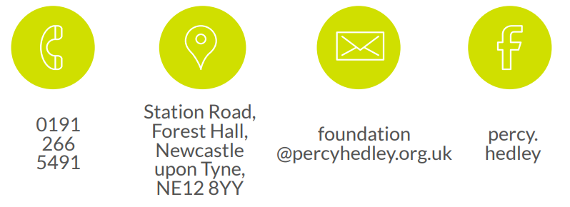
We are committed to safeguarding and promoting the welfare of children, young people, and vulnerable adults. Applicants should be aware that the post will only be offered to successful candidates subject to an Enhanced DBS check as well as other employment clearances.

