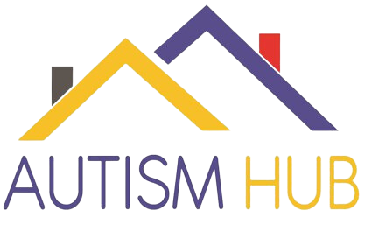
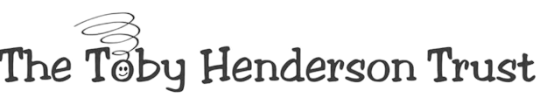
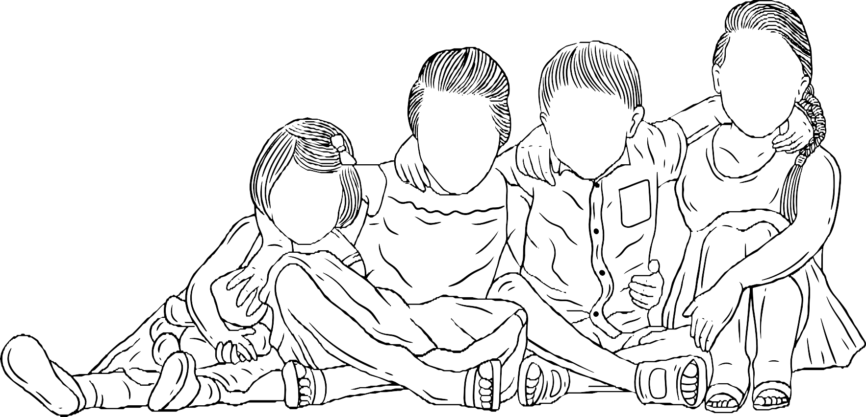
PLACES ARE LIMITED. To register your interest please email: autismhub@ttht.co.uk or call 0191 816 0550.

Tuesday 9th April 2024 | 10am - 3pm

at: Autism Hub, Gordon st, South Shields.
This is a free 1 day workshop during the Easter break for children/YP aged
8 - 17years living in South Tyneside, who have an autistic sibling or a sibling undergoing the diagnostic pathway. The workshop will be delivered by Autism Service Manager Lynda Richardson, Autism Hub Manager Fiona Richards and members of the Hub team. The aim of our full day workshop is to give siblings a safe space specifically for them, where they can meet others in a similar position and join in with fun and focused activities to help equipped them with knowledge and strategies, and most importantly to help them feel empowered.
Research has shown that living with a sibling who has a disability can impact on a young person’s wellbeing, educational attainment, and even lifelong achievements (Sibs. 2013). At The Toby Henderson Trust we recognise the importance of acknowledging just how hard life can be as a sibling to an autistic person, but also (and perhaps more importantly) just how rewarding it can be too. This workshop will explore the challenges siblings may face and/or feel and how they can support themselves.

