   
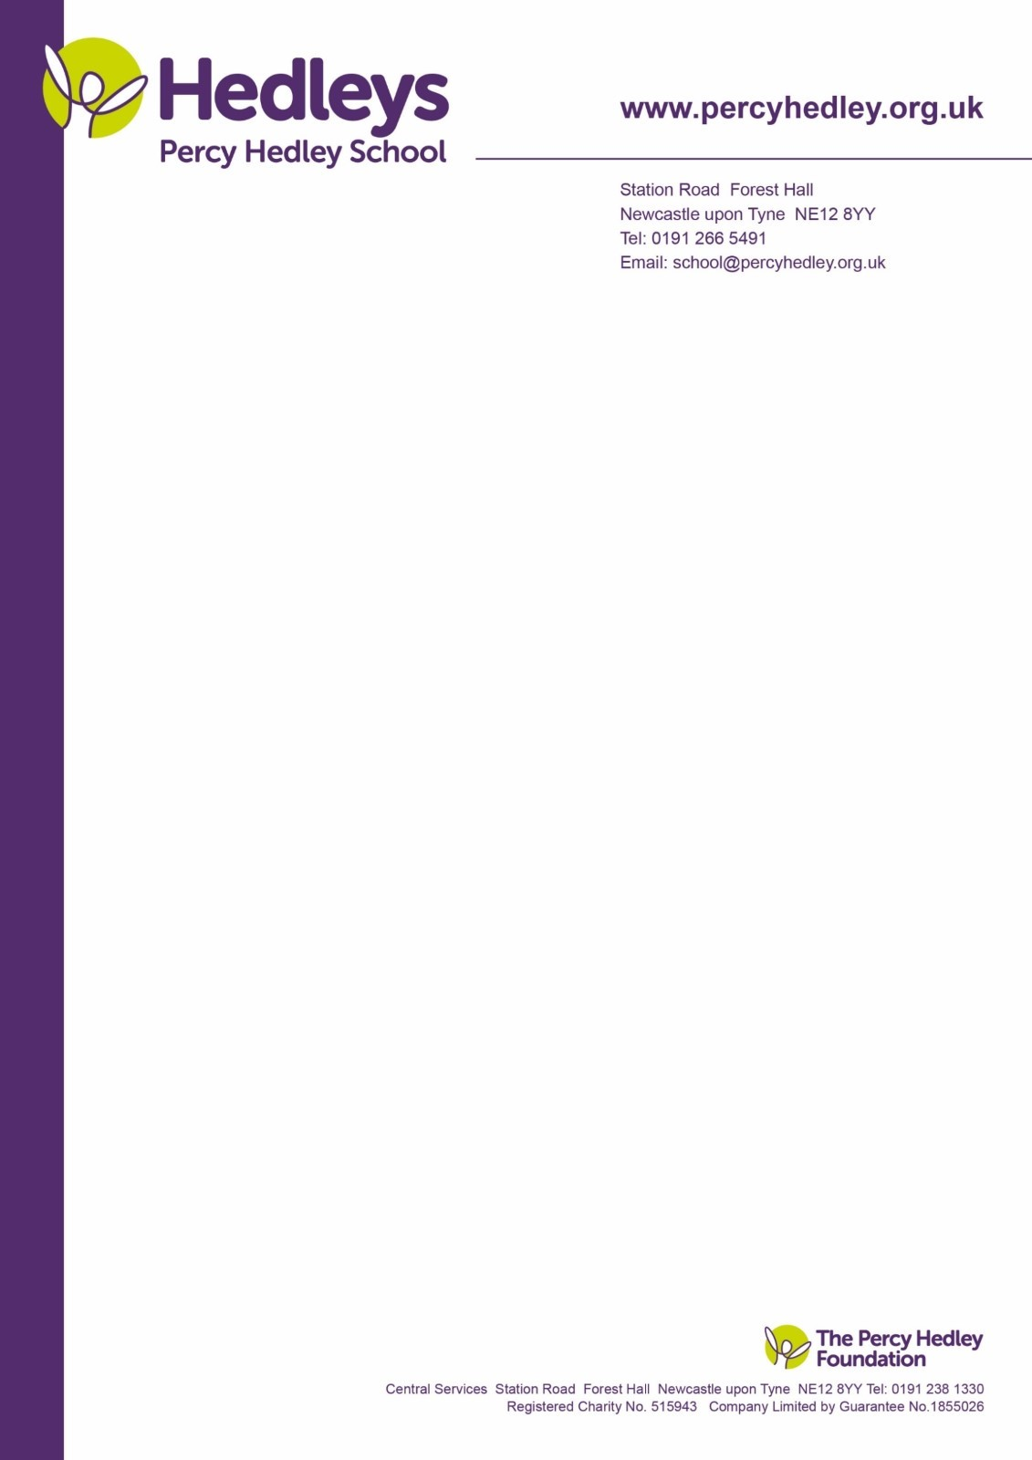

28th Feb 2024

Dear Parents/ Carers,

As you may have read about on our blog recently, it’s World Book Day time again! We will be celebrating **World Book Day** on **Thursday 7th March**, with the theme ‘Read your way!’

Book Day 2024 will celebrate that children are more likely to enjoy reading when their choices are championed and we make reading fun. We are passionate about developing a love of reading within our students and are excited for a lovely excuse to celebrate this further!

There will be opportunities throughout the day to celebrate reading and our love of books however we invite students and staff to:

* Bring their favourite book in to school to share in class.
* Bring in or email (your teacher) a photo of you reading your way, or your favourite space to read! Do you have a cozy seat you like best? Share how you read your way!
* As always, those who choose to dress up as their favourite book character are welcome to, but in the theme of ‘Read your way’, we also welcome students to come to school in their pyjamas or cozy clothes! We understand that change and dressing up does not work for everyone, so please be reassured that there is no pressure on this. On the day some people will be dressed up in costumes or their cozies, and others won’t – we will be celebrating together either way.

If you have any queries please contact your class teacher or [r.finn@percyhedley.org.uk](mailto:r.finn@percyhedley.org.uk)

Thank you for your support!

The Literacy Team