##### 

***ST. PATRICK’S DAY IDDSI 3, 4 & 5***

*15TH MARCH 2024*

|  |  |
| --- | --- |
| **Irish Corned Beef Stew** | **Mashed Potatoes** |
| **Carrots** | **Mashed Swede** |
| **Cake & Custard** | **Lemon & Lime Mousse** |

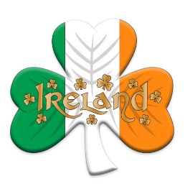

***ST. PATRICK’S DAY***

***VEGAN & VEGETARIAN***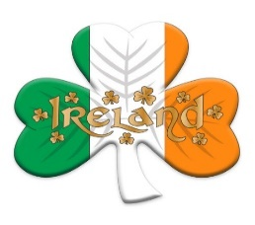 *15TH MARCH 2024*

|  |  |
| --- | --- |
| **Vegan Quorn Beef Stew** | **Colcannon** |
| **Irish Cabbage with Vegan Crispy Bacon** | **Irish Soda Bread** |
|  |  |