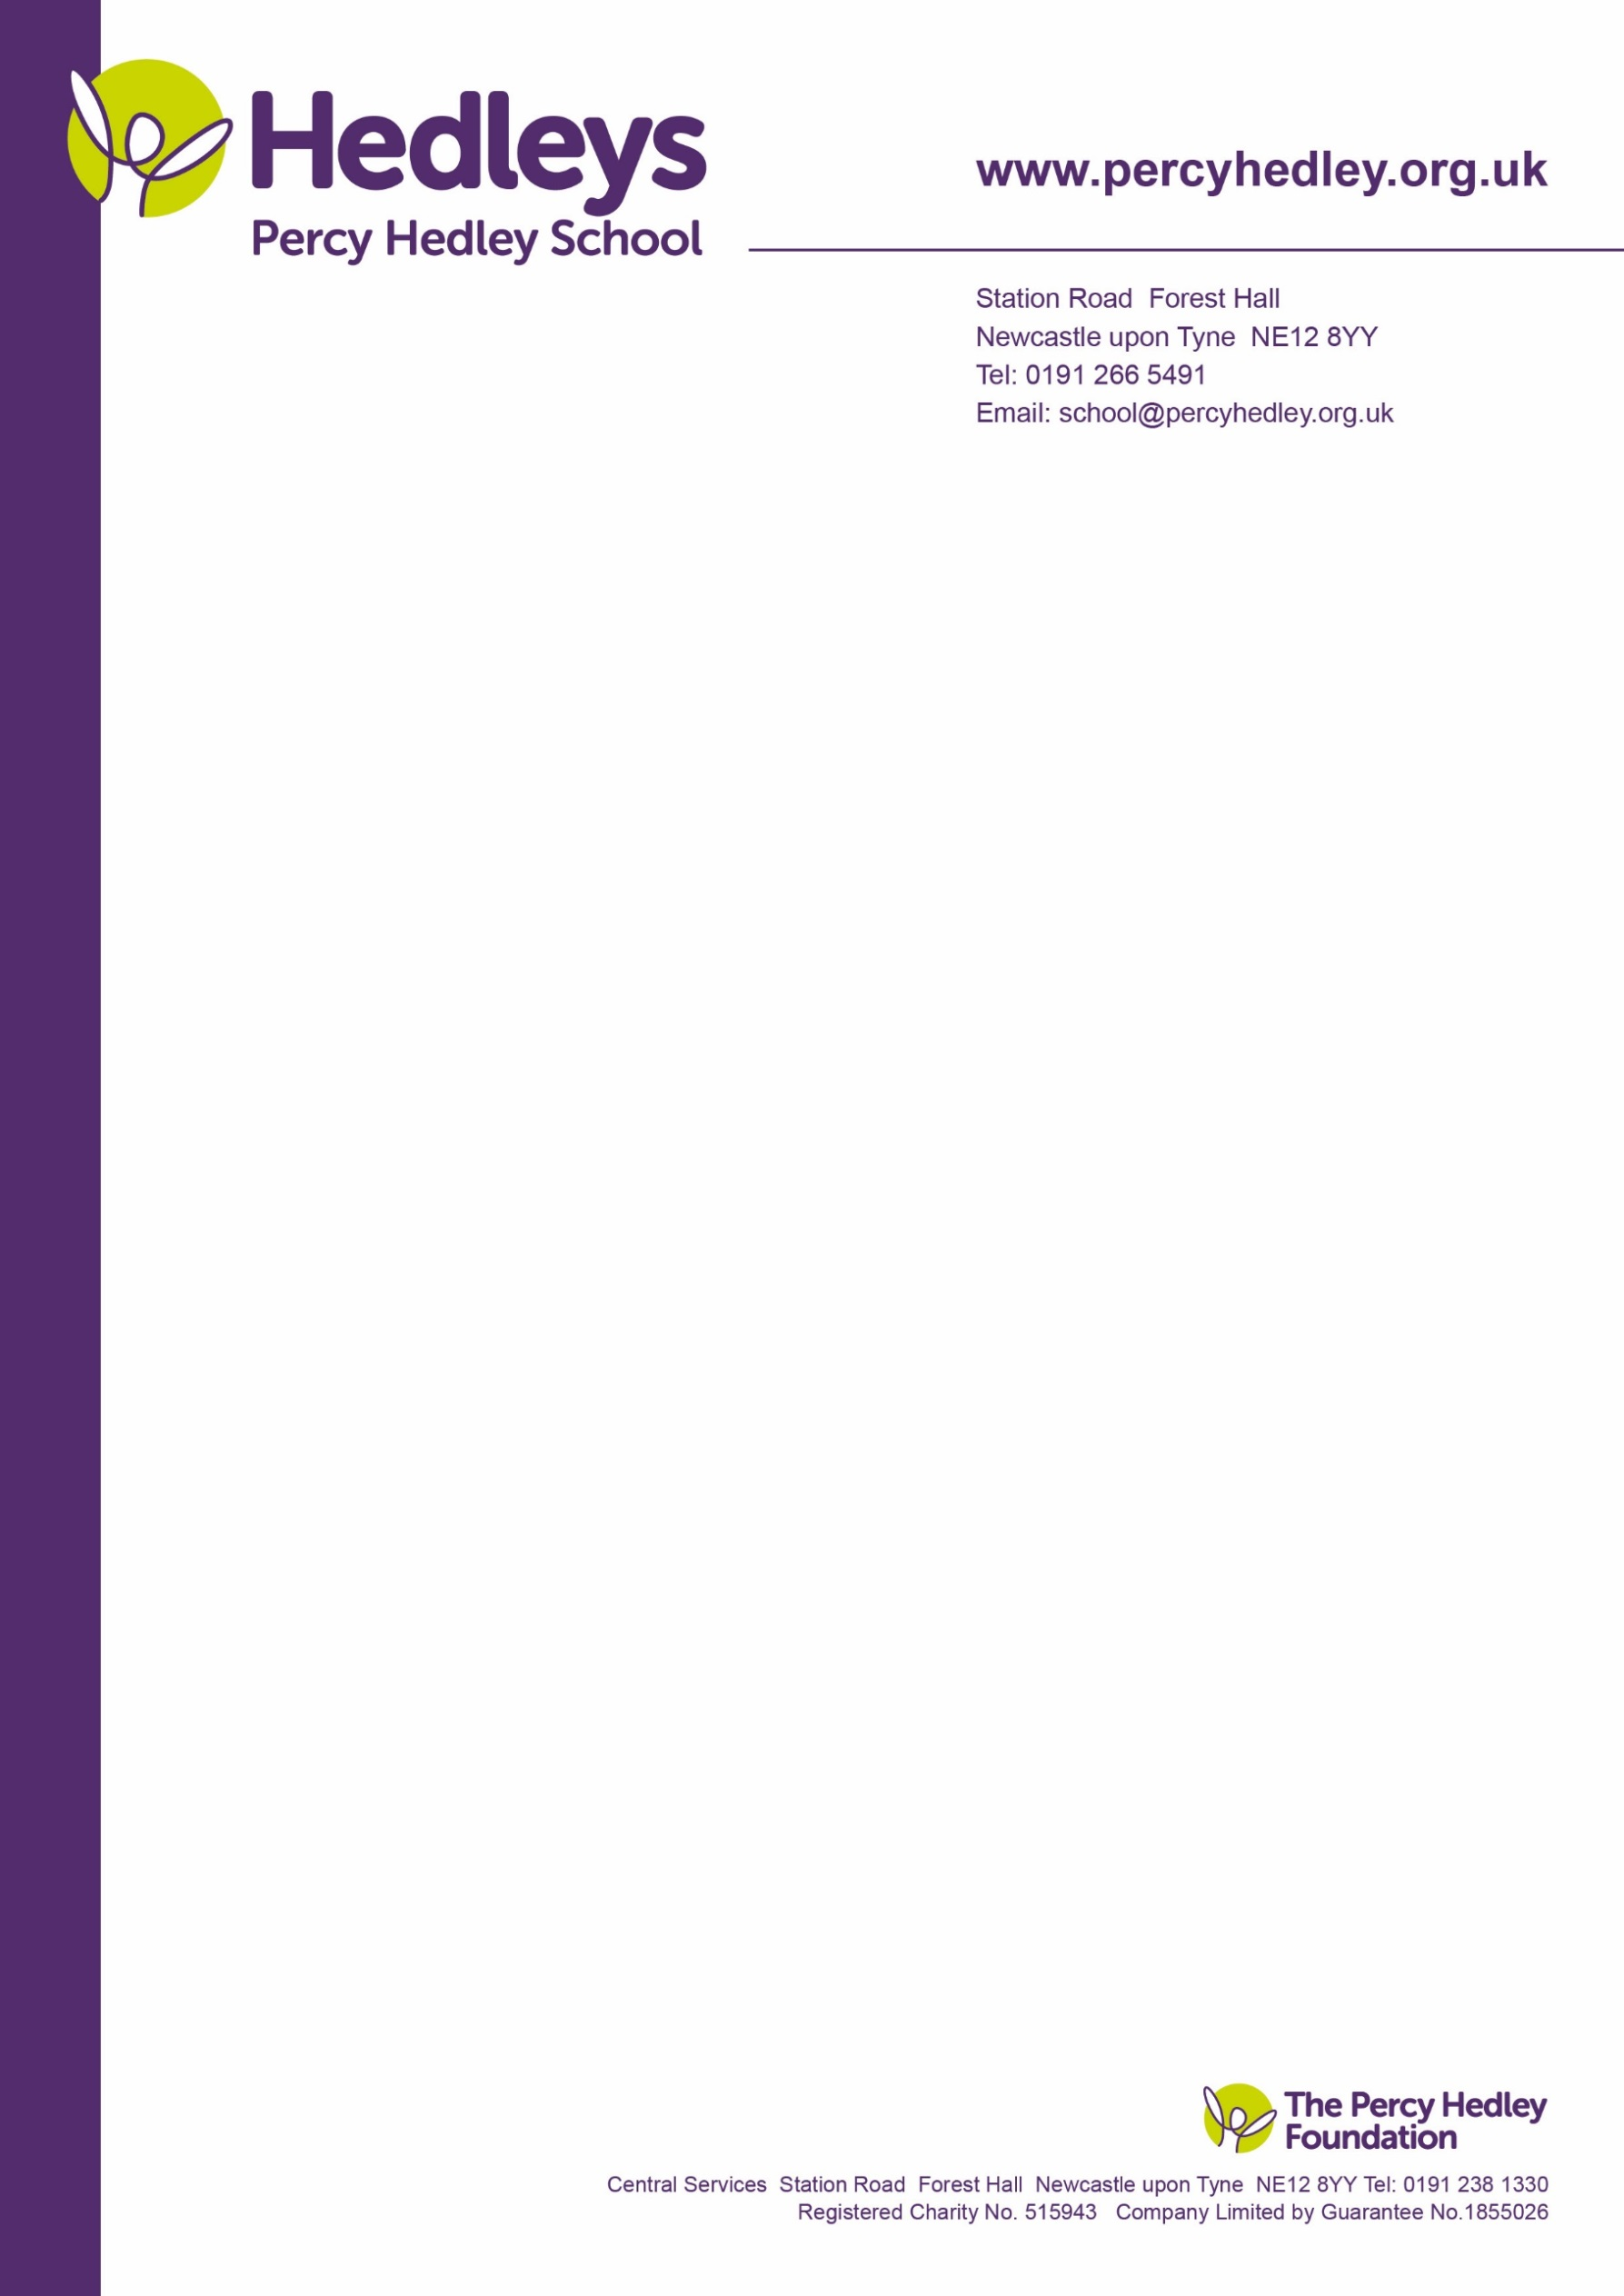

Dear Parents/Carers

Mother’s Day Sale

This year we will be hosting the annual Mother’s Day sale on the 8th of March.

We will give more details about the event closer to the date. The student council is asking you for any donations of any unwanted gifts. We will then sell the gifts for £3 at the sale.

If you could please send any gifts to Kayden or Amanda, School Council.

We are a nut free School so please avoid anything containing nuts. Also, we are unable to accept any gifts of alcohol as we can’t sell these on to the students.

Many thanks for your help.

Chair of Student Council: Kayden

Staff Chair of Student Council: Amanda Waugh



West Lane, Killingworth

Newcastle upon Tyne, NE12 7BH

Tel: 0191 216 1811

Email: school@percyhedley.org.uk