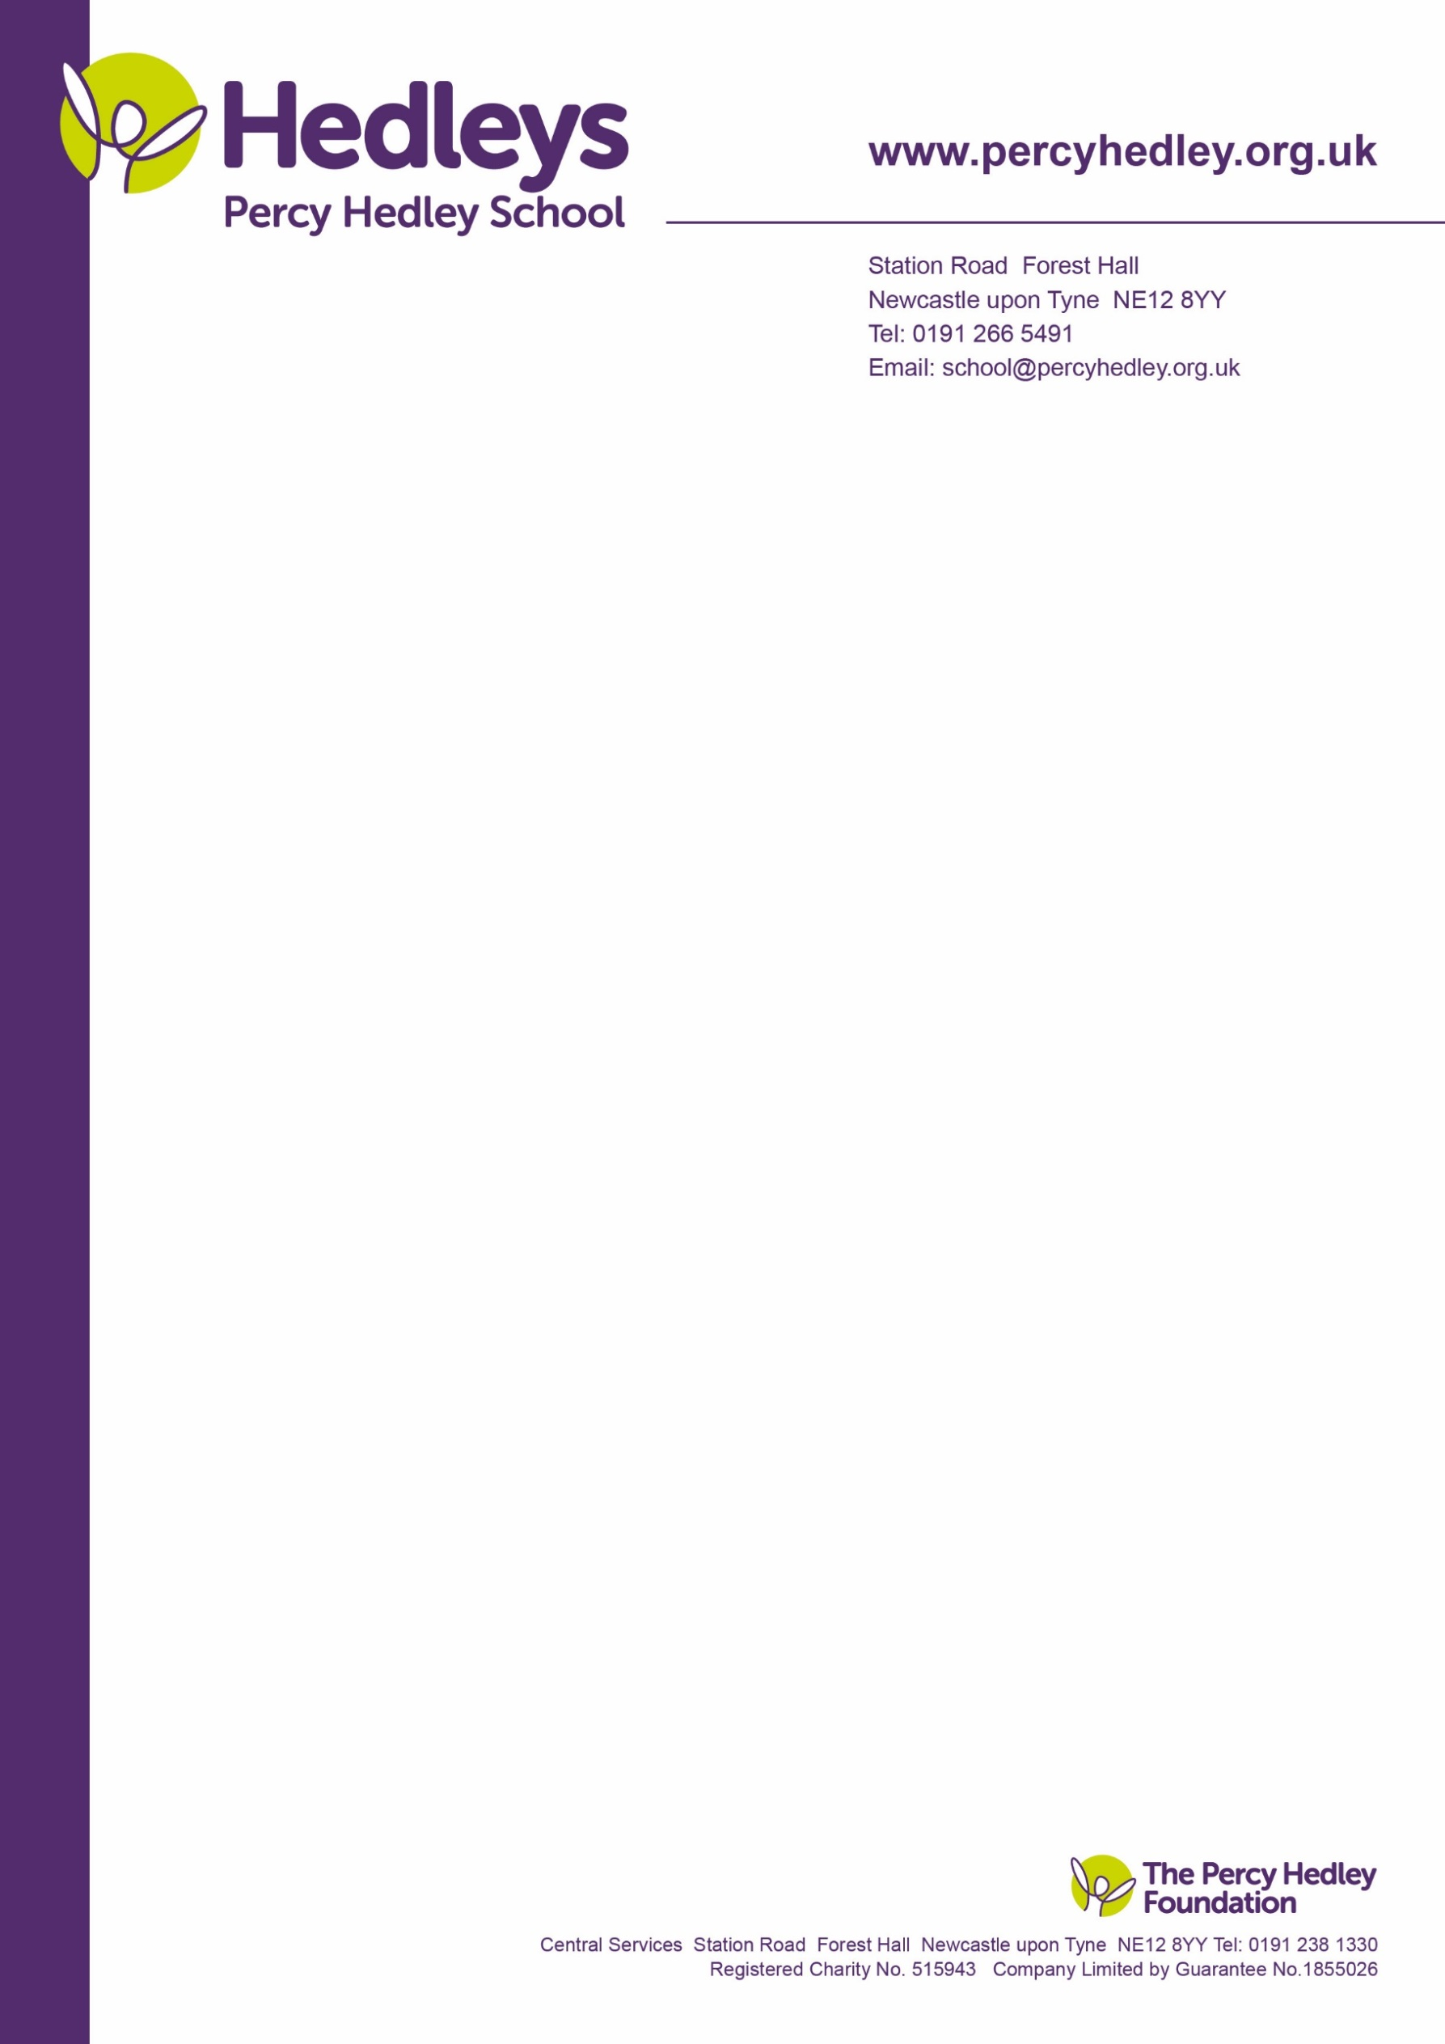

Dear Parent/Guardian,

Students from Post 16 will be selling tricks and treats to students and teacher at Percy Hedley School from Monday 22/10/2023 to Friday, in order to raise money as part of their Enterprise Halloween Module. This is a fantastic opportunity for students to enjoy Halloween goodies and learn how to run a small business. Our cohort has come up with a range of products that will be sold throughout the week.

**Monday (23/10) - Spooky Cinema (first come first serve) and Graveyard Brownies**

**Wednesday (25/10) - Spooky cookies, Halloween Crafts and stickers**

**Friday (27/10) – Spin the wheel and Candy Floss**

I hope you will be able to support our students with their enterprise ventures. Please feel free to allow some spending money for your children to treat themselves.

Your Sincerely,

Miss Kasia Grzelak

West Lane, Killingworth

Newcastle upon Tyne, NE12 7BH

Tel: 0191 216 1811

Email: school@percyhedley.org.uk

20 October 2023