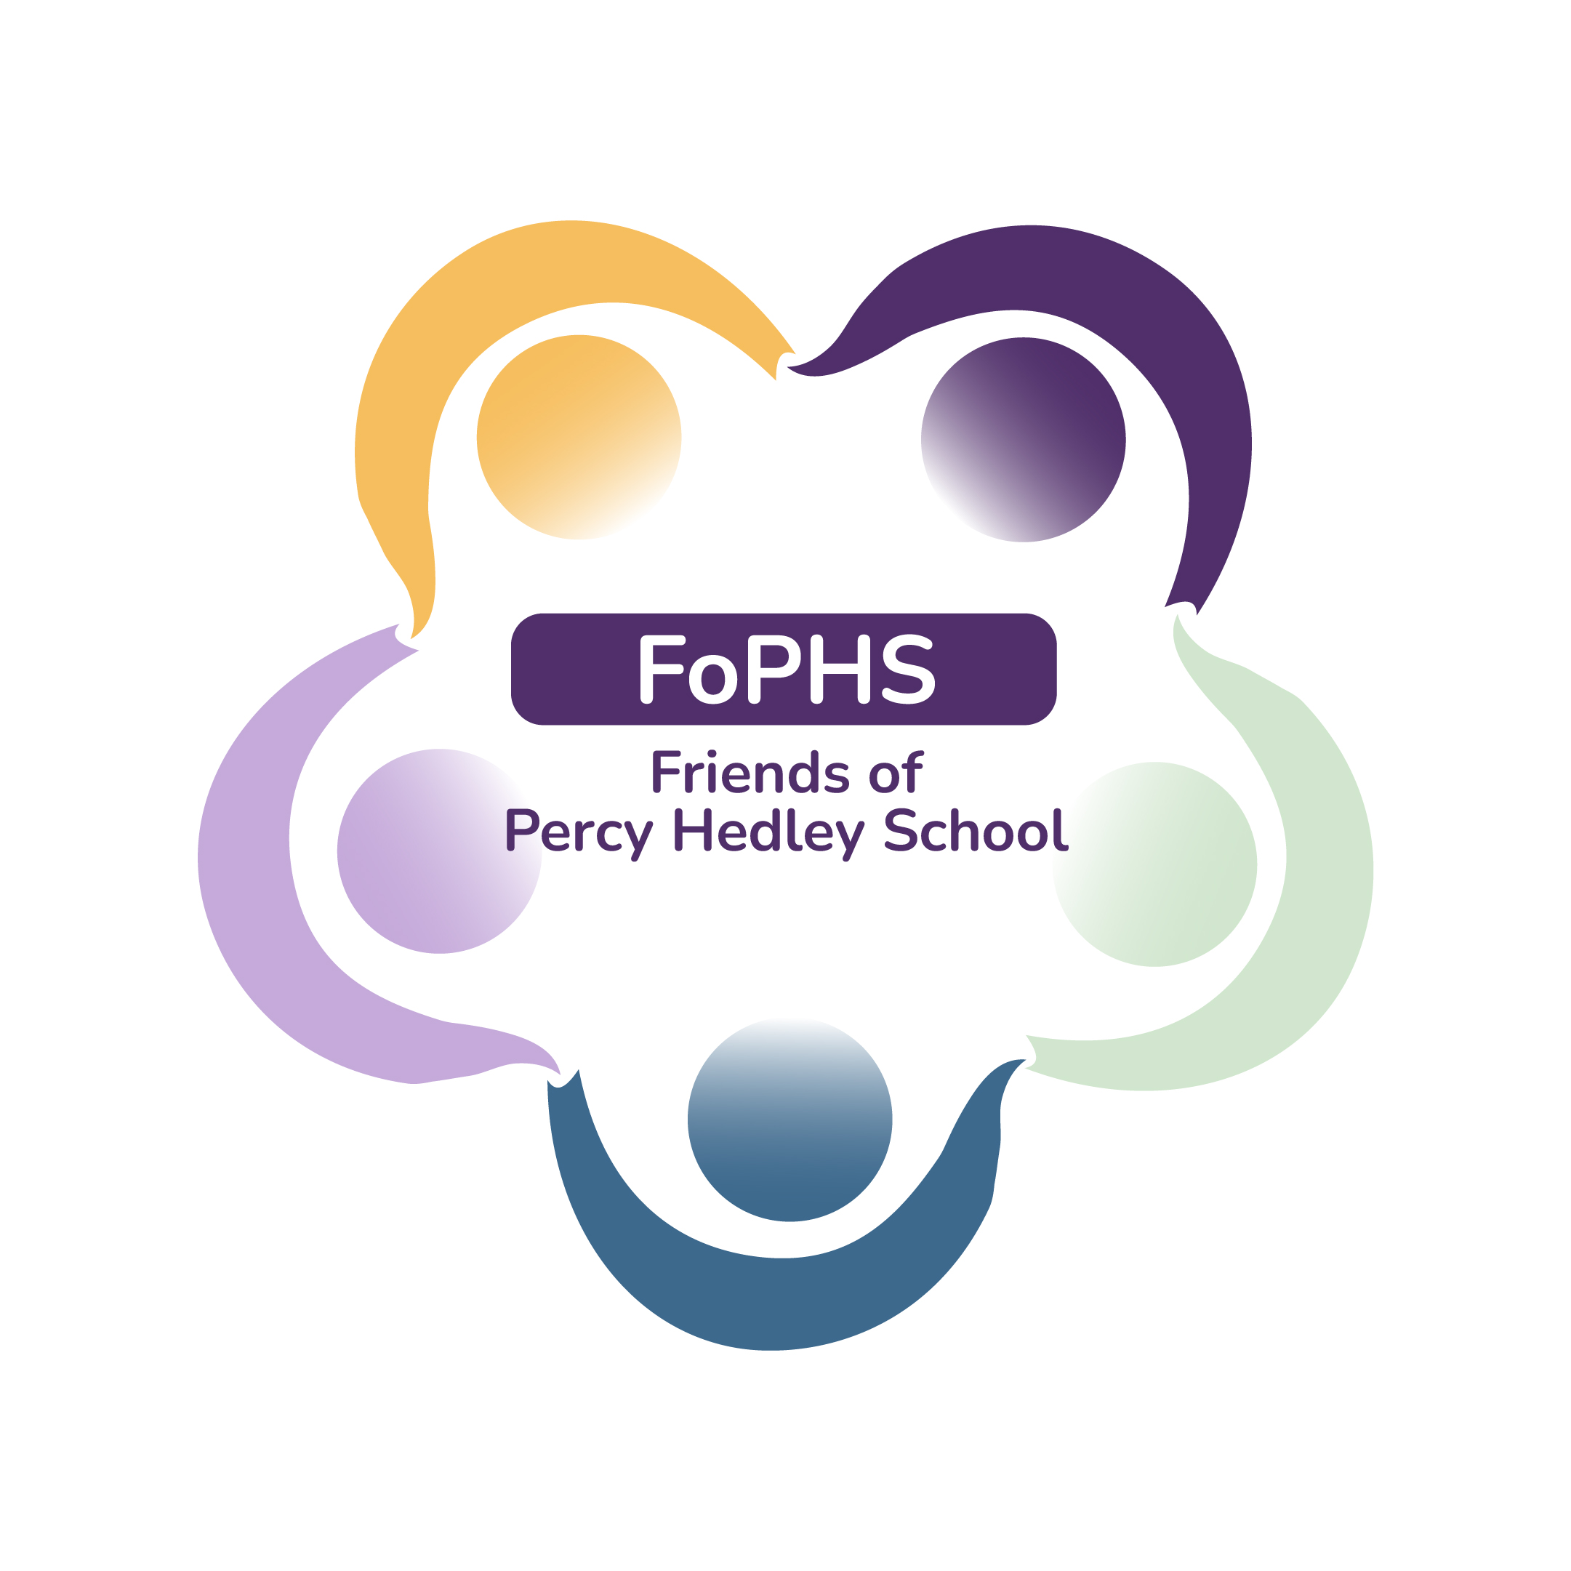
Percy Hedley FoPHS 100 Club - £12 per number

CHEQUE/CASH

I would like to subscribe to .............. number(s) for the 2023-24 school year and enclose a cheque/cash for £............ (cheques to Percy Hedley Foundation). If you would prefer a specific number please write this down here.....

Please put your (child’s) name & class on the back of cheque. Send this to Eileen Robinson PTA to make sure you are included in the draws.

There will be 1 draw each month with 50% of takings go to the winner & 50% to FoPHS funds. Total cost for the year is £12. These will be drawn in February and July (6 draws each time).

Last year we raised £576 for FoPHS. All funds raised by/donated to the FoPHS are spent on class experiences, resources which would not be funded by school fees. They benefit all students. If you have friends or family who would like to join, please share this with them. Please email me if you would like additional information or forms. Thank you for your support. It really makes a difference.
Eileen Robinson. Email: e.robinson@percyhedley.org.uk

N.B: PLEASE ENSURETHAT ANY CHEQUES/CASH ARE HANDED TO A MEMBER OF STAFF BY YOU, or your CHILD’S ESCORT & ARE CLEARLY LABELLED (fao E Robinson). Ideally drop me an email so that I know they are coming
Signature ................................................ Date.....................................

Name:..................................................................................
Please note name above is what we will use to write winners cheque

Address:......................................................................................................

…………………………………………………………………………….............

…………………………………………………………………………………….

E Mail:.........................................................................................................
Tel no:……………….
Child’s name: …………………………………….. Class: ………

