The Percy Hedley Foundation Careers Strategy : 2023 - 2024
Updated April 2023

Our Vision
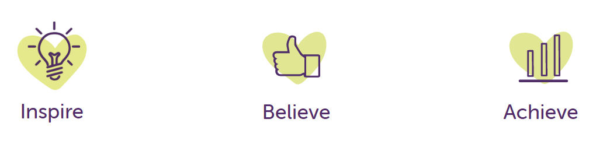
We want to inspire positive change by
helping everyone understand disability.
We help people develop their abilities,
live the life they want, and be happy, by
providing top quality care, education,
and lifelong learning opportunities.

Careers at Percy Hedley Foundation
Our Vision:
Our vision is to support, engage and enable students and members across the Foundation to build confidence, resilience and motivation in order to achieve their full potential. Introducing them to experiences which help them to develop their talents and fulfil their ambitions.

Our Careers Strategy: Introduction
Our commitment
There has never been a time when careers guidance has been as important for young people as it is at present. The world of work and employment is changing rapidly. The Foundation has a critical role to play in preparing our students and members for the next stage of their education or training and beyond.
With the greater choices of education, training and employment, our aim is to prepare students and members for these ever-changing opportunities, responsibilities and experiences and to equip them with the skills to manage the choices, changes and transitions ahead of them.
Our Values
Our values guide everything we do. These values and beliefs define what is important to us at the Percy Hedley Foundation.
We Inspire others: We seek out opportunities to inspire and support our students and members to achieve their ambitions
We continually seek to improve: We recognise that our work has a positive impact on our students, members and their families/carers, improving outcomes for all. We work tirelessly to improve the lives of all.
We work together – one team, one Foundation: We work together as one Foundation this way we achieve more than individual services would achieve alone
People are at the heart of everything we do: Each and every student and member is placed at the centre and treated as a person first. We focus on the individual and what they can do, not their learning difficulties or disability. Our support focuses on achieving the individual’s aspirations and is tailored to their needs and unique circumstances.
We do the right thing: We do the right thing for each student and member no matter what.

Aims and Objectives
The careers education, information and guidance programme is designed to meet the needs of every student and member of the Foundation.
We aim to raise aspirations, challenge stereotypes and encourage students and members to consider a wide range of careers and work related learning. A progressive and structured programme, which reflects the specific needs related to the difficulties of our young people is important therefore, to ensure smooth transitions at all stages. The careers education and guidance programme will provide activities, experiences, information and important evidence to empower students and members with their parents/carers to make informed decisions. It is differentiated to ensure progression through activities that are appropriate to our student and members stages of career learning, planning and development.
The main aims of the careers provision within Percy Hedley Foundation are to:
- Deliver a careers programme across the Foundation which responds to individual need and delivers equality of opportunity whilst promoting lifelong learning and personal development.
- To raise and track student and members engagement within the careers programme during their journey through the Foundation and evaluate to ensure that students and members are supported in raising their aspirations through a person centred approach
- Build a continuously increasing and relevant network of partners and providers who can engage students and members in developing their career pathways, where appropriate.

Roles and Responsibilities of Headteacher, College Principal, Careers Leader, teachers, teaching assistants and Governors

The Headteachers, College Principal and Head of Service for Horizons will ensure that:

• all statutory elements of the curriculum are met.

• the amount of time for teaching the curriculum is adequate and reviewed annually.

• the governing body is informed on the breadth and balance of the curriculum

• this policy is implemented and monitored and the governing body is reported back to termly.

• a positive lifelong learning culture in which all students and members believe that they can succeed is promoted across the Foundation.

• there are high standards of teaching and learning in education.

• the Foundation is compliant with legislation and will enable an annual evaluation of Careers across the schools and college.

The Careers Leader will ensure that:

• guidance is followed in line with an appropriate careers audit using the Compass and updated when necessary throughout the year

• student and members summative progress is monitored and evaluated in work files

• Individual benchmarks are completed and updated annually

• Individual outcomes are updated each term, personal tutor is responsible for this in College

• students and members have access to a deep learning careers week

• appropriate accredited courses are followed where applicable, PHSE, ASDAN, NOCN

• all long and medium term plans for the subject are kept up to date, personal tutor is responsible for this in College

• students and members have the opportunity for individual, impartial careers guidance interviews with experienced staff at key decision points

• subject resources are kept up to date and available for all staff, when appropriate

• teaching of careers is relevant across all stages in school and college, where appropriate

• students from year 7-14 have access to encounters with a variety of employers and businesses

• relevant FE providers have access to students from year 7 -14 to inform them about the varied career options open to them and courses and qualifications they offer and what each option entails.

The Staff Team will ensure that:

Students and members gain an understanding of the world of work and will understand their entitlement to lifelong learning.

• Link the curriculum learning with careers, where appropriate

• Importance of succeeding in English and Maths in education is shared, where appropriate

• They highlight the relevance of Science for a wide range of future career paths (not applicable in college or Horizons).

• All subjects that are taught, should highlight the relevance of the subject for a wide range of future career paths

• Students and members know and understand how to access sources of career/future learning information and decision making support.

• Assessment informs students and members of their next steps in lifelong learning.

• They contribute a subject comment to students and members reports.

• Develop transferable skills

• Students and members have access to a variety of opportunities in investigating other careers,

e.g. self-employment, where appropriate

• Students and members have an awareness of a variety of paths that they can follow in order to achieve success in a chosen employment area, where appropriate

The governing body will ensure that:

• it considers advice from the Head Teacher/ Principal/Head of Service when approving this strategy

• the progress of students and members is monitored and evaluated

• the breadth, balance and financing of the strategy is regularly monitored

• test and assessment data is monitored

• parents and carers receive regular reports regarding the progress, where appropriate

Parents/carers will play a major role in this process, and in finding out about the opportunities available in carrying out the plans they make. The team will maintain regular links with parents/carers during stages of transition, to monitor progress towards securing future placements. Parents/carers are able to contact the team at school/college/horizons to discuss comments and ask questions, meetings can also be arranged if required.

The Careers Service, are key partners in the provision of Careers Education and Guidance. We have a clear commitment to working together in the provision of the careers education and guidance programme and in providing specialist careers information and support.

The Beyond Team

The aim of the team is to deliver a successful Employability Programme across the Percy Hedley Foundation by engaging with employers and other stakeholders. In order for students and members to reach their full potential.

We will do this by increasing public, private and voluntary sectors awareness of working with adults and young people with disabilities. Supporting the community and employers to gain insight into the abilities of people with disabilities and raising the aspirations of the people themselves.

We will increase the numbers of adults with disabilities in employment or on the pathway to employment. This will be achieved through building a network of supportive employers and creating real work experiences for students and members across the Foundation.

We will support students and members to find meaningful paid or voluntary opportunities

• We will organise realistic work experience visits, placements, workshops and employability activities for learners and members in conjunction with Foundation staff.

• Be point of liaison for all PHF services to approach about a work placement and match to an employer on the database, making first contact with the employer.

• Keep up to date with relevant information relating to disability and employment.

• Make, maintain and share appropriate records and reports, as a means to continually track progress and develop the offer.

The Gatsby Benchmarks
An overview of the Gatsby Benchmarks
Following the success of the Benchmarks pilot in the North East of England, the wording of the Benchmarks was refined, in consultation with a number of colleges, to produce a version specifically aligned with colleges. The Benchmarks for both schools and colleges were adopted into the Governments statutory guidance for schools and colleges in England from 2018.
Expertise from the SEND Sector:
As part of the pilot from experienced SEND practitioners across the North East, along with national advocates formed a SEND working group. Drawing on their expertise from across special and mainstream schools, and developing
careers programmes in different settings, they gave us the clear message that the Benchmarks provide an aspirational framework that works for
each and every student.
“Good careers advice and guidance can make a huge difference to the lives of students with Special Educational Needs and Disabilities (SEND). Our young people want to fulfil their ambitions and be contributing members of their
community. The Gatsby Benchmarks help deliver the information and
encounters that will allow this to take place, and I welcome their adoption by government.”
Council for Disabled Children, Dame Christine Lenehan, Director

https://www.goodcareerguidance.org.uk/assets/file?filePath=send/good-career-guidance-perspectives-from-the-send-sector.pdf 20/4/23

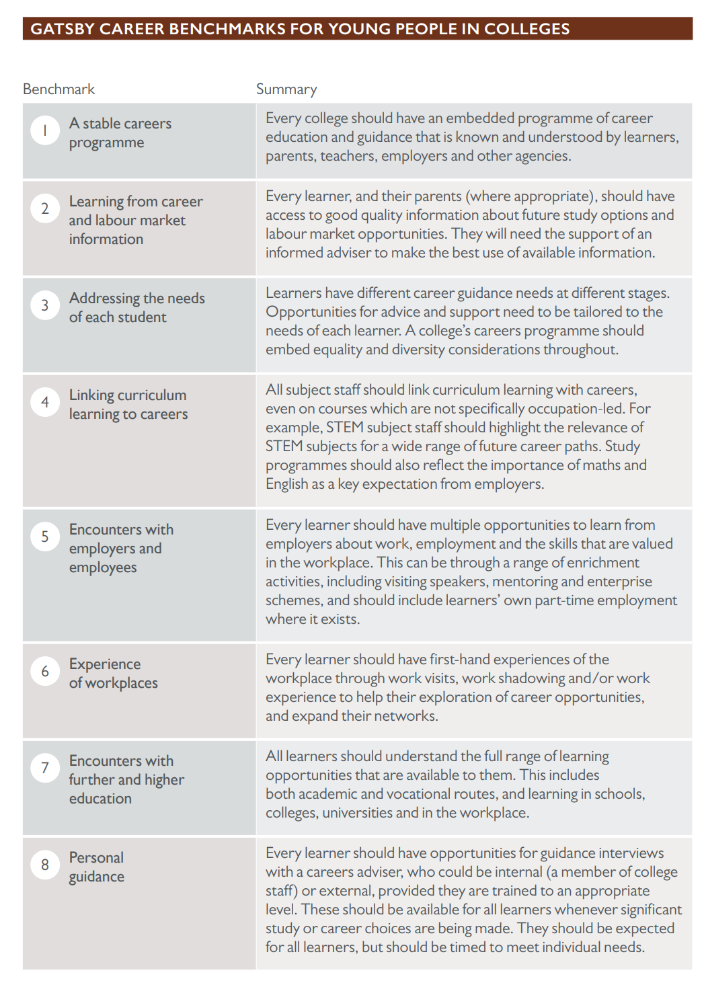
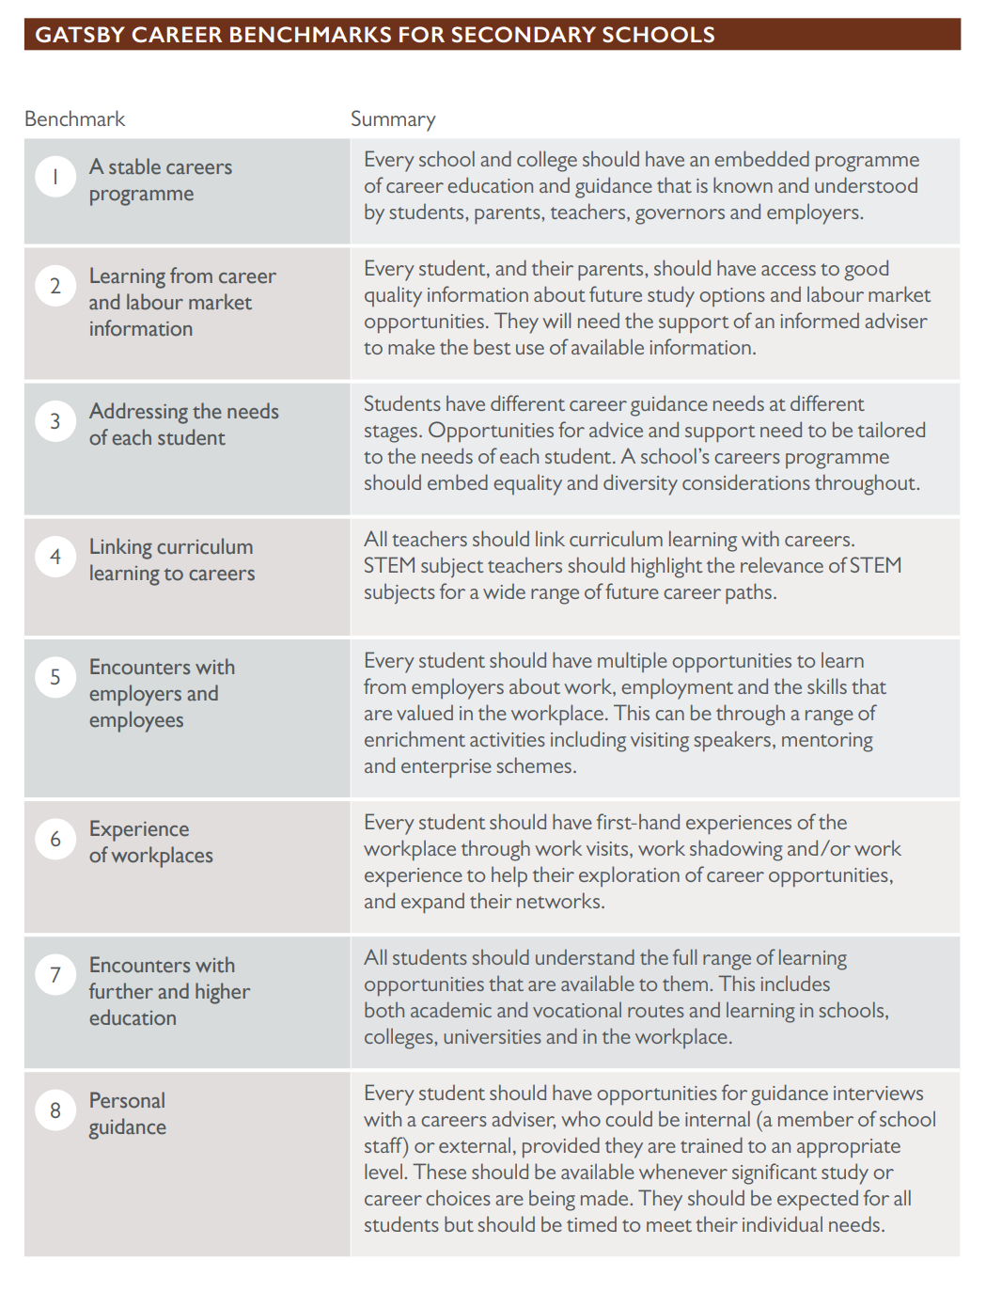

Careers at the Percy Hedley Foundation
Our Strategic Objectives
Strategic Objective 1:
Deliver a careers programme across the Foundation which responds to individual need and delivers equality of opportunity whilst promoting lifelong learning and personal development.
Benchmarks 1, 2, 3, 4, 7 and 8
Year | What will success look like (Targets)  What do we want to achieve? | What actions we will take as a Foundation  to achieve these targets?
Year 1 2023-2024 | - A comprehensive programme of age-specific Careers Education is in place throughout the curriculum.  - The pathways across the Foundation enable all learners and members to develop their own personal career pathway.  - All eligible students and members will have a live vocational profile  - Student and member survey shows that learners are excited about different jobs and can all name a range of careers and career pathways, where appropriate  - Students and members can understand the link between their learning in each subject area and their future career pathways, and every eligible student and member can identify career pathways in all aspects of their learning.  - All students and members will know their strengths and capabilities and be supported to focus on future aspirations  - All students and members will be involved in work related learning opportunities | - Update the CEIAG area of the school and college website.  - Share updates with parents through social media platforms, blogs and newsletters.  - Every eligible student and member will be supported to complete an experiential Vocational Profile, which will capture the voice of the student and members to match pathways that suit their interests and abilities.  - All students and members have a robust assessment at induction and this is reviewed regularly to develop a person centred careers programme.  - Parents/carers will be engaged with to add their observations and knowledge of the student or member to the vocational profile document.  - Careers leads will arrange strategic discussion meetings with the named Governor for careers, to include the Beyond team.  - Sessions to be arranged to include Parents/carers for careers discussions. These will provide opportunities for parents/careers across the Foundation to build networks together.  - Careers IAG sessions are designed with the person in mind, whilst adhering to the CIAG professional charter.

Strategic Objective 2:
To raise and track student and members engagement within the careers programme and evaluate to ensure that students and members are supported in raising their aspirations through a person centred approach
Benchmarks 1, 2, 3, 5, 6 and 8
Year | What will success look like (Targets)?  What do we want to achieve? | What actions we will take as a Foundation to  Achieve these targets?
Year One (2023-2024) | - All eligible students and members have experienced a range of different careers experiences to enable them to develop their own future pathway.  - All students and members will know their strengths and capabilities and be supported to focus on future aspirations  - Former students and members are invited into school and college to inspire the next generation.  - All eligible students and members will have a vocational profile which correctly records assessment data and progression data | - Develop and maintain systems which evaluate progress made toward achieving person centred aspirations  - Creation of a careers database to record all individual /group careers engagements.  - All 1:1 careers guidance to be shared appropriately and recorded within the school/college systems  - Engagement with the Beyond team is recorded analysed and shared with the careers teams on a monthly basis for learning and review purposes  - Initial student, members views on future careers to be collected at induction to the Foundation and recorded in individuals files.  - Workplace visits are evaluated to inform future planning. All employers are asked to complete evaluations after visits.  - Parent/carers views to be surveyed where appropriate following student, member, employer engagement sessions.  - Former students, member and parents/carers to be invited to return to careers related events.

Strategic Objective 3:
Build and continuously increase partnerships with employers to offer a variety of experiences within the world of work.
Benchmarks 1, 2, 3, 4, 5, 6, 7 and 8
Year | What will success look like (Targets)?  What do we want to achieve? | What actions we will take as a school to achieve these targets?
Year One (2023-2024) | - Each subject area within school, and the college learning programmes to have established a link with a local business/employer and to have developed their own collaborative work to engage learners.  - All students and members to have completed a variety of work experiences opportunities, in their home areas, where appropriate  - All students and members will have experienced community events in their home communities  - All employers working in partnership with the Foundation will have the opportunity to access the Percy Hedley Disability Awareness training.  - Students and members across the Foundation will have co-produced the disability awareness sessions  - Students and members will have co-produced a new work experience offer with one employer  - Students and members will be included in reviewing resources aimed at those with disability to support learning in the workplace | - All eligible students and members embark on a work placement during the year and record their experience.  - Annual Careers week will invite local business, training providers and further and higher education providers to engage with the students and members across the Foundation.  - Arrange with local FE/Universities to visit school/College and/or learners to visit their sites to experience what they have to offer.  - Run a termly business breakfast (or similar) to encourage greater local partnerships with employers/businesses.  - All students and members to have community volunteering opportunities shared with them  - All students and members to have community sessions within their own home communities  - Review and deliver disability awareness sessions with employers to build relationships  - Create working parties of students and employers to review and support continuous improvement in employment

