Adult Support Worker - BSL
Service: | Adult Residential
Responsible To: | Registered Manager
Salary: | Points 8 - 10

Job Purpose
To provide personal care and support to adults with physical and/or learning disabilities in a residential home environment.

Main Duties
- To provide personal care and support to residents in accordance with their Care Plan
- To ensure a safe, caring, positive and stimulating home environment for residents using Intensive Interaction and Positive Behaviour Support Strategies
- To ensure a high standard of care is provided in line with current regulations and Care Quality Commission standards
- To support the effective application of Safeguarding tools in accordance with relevant guidelines
- To enable residents to develop and maintain their skills to live independent and fulfilled lives e.g. cooking, cleaning, shopping, accessing community facilities
- To promote dignity and respect ensuring residents choice and control
- To be aware of risks to residents, follow risk assessments and promote a positive risk taking culture
- To support the development of new or less experienced staff to carry out duties within their job description
- To take on responsibility for leading a shift when requested in the absence of a Senior Support Worker
- To promote excellent health and safety practices at all times within the residents home and when supporting residents in the community.
- To be aware of infection control issues within the home, ensuring high standards of personal hygiene and a clean environment are maintained at all times
- To administer medication to residents in accordance with procedures and training
- To be aware of Policies and Procedures relating to the provision of services
- To ensure written records for residents are completed to a high standard
- To ensure incidents, accidents and safeguarding issues are recorded accurately in the appropriate logs
- To act as Care Co-ordinator to an individual resident as required
- To liaise with other foundation services involved with residents including Horizons and Hedley’s College
- To liaise with family, friends and health / social care professionals on behalf of residents as required
- To enable and encourage social activities both in the home and within the local community
- To escort residents as required and drive Foundation and/or Motability vehicles where a valid license is held
- Any other reasonable duties relating to the residents needs

Person Specification

Essential Criteria
Skills and Knowledge
- Good written/verbal communication skills
- Good organisational skills

Qualifications and Training
- Level 2 qualification in Literacy and Numeracy
- Valid BSL qualification
Personal Qualities
- Able to work on own initiative
- Confident to communicate effectively with families, carers and social care professionals
- Flexible, enthusiastic, committed
- Good team member
- Caring and empathetic

Other Requirements
- Able to work Early/Late/Weekend shifts

Desirable Criteria
Skills and Knowledge
- Good I.T. skills
- Knowledge of working with adults with disabilities
- Knowledge of CQC standards
- Understanding of challenging behaviour and Positive Behaviour Support.

Qualifications and Training
- Care Certificate
- Level 2 qualification in Health and Social Care
- Moving and handling of People

Experience
- Providing personal care and support

Other Requirements
- Flexible and able to extend hours of work if required

Organisational Standards
The Percy Hedley Foundation operates in a demanding and often changing environment. Members of staff must be flexible, adaptable, willing to face up to changing circumstances and new opportunities. The following list of duties and responsibilities must therefore be taken as a guide and is not to be comprehensive.

Professional Duties
- Participate in the review of the Foundations Policies, Procedures and Processes;
- Participate in arrangements for the performance development review process
- Participate in arrangements for further training and professional development
- Keep up to date with changes or developments within your professional area
- Fully participate in the induction and training programme provided by the Percy Hedley Foundation
- Contribute to the professional development of other staff, including the induction of new staff.

Equality and Diversity
- Promote equality of access to education, training and employment opportunities for disabled people, and advocate a positive attitude
- Recognise that disabled people are individuals who have specific needs
- Employ support strategies that will empower disabled people
- Show awareness of knowledge and display non-discriminatory behaviours at all times in relation to culture, race, ethnicity, disability, gender, sexuality and age
- Recognise the importance of inclusion by using appropriate means of communication at all times
- Be flexible, trying to meet the changing needs of both disabled people and environment.

Discipline, Health and Safety
- Adhere to and promote Percy Hedley Foundation Health, Safety and Welfare policy at all times
- Purchase equipment from a recognised source
- Report all incidents and accidents to Health and Safety Officer
- Maintain a high standard of record keeping in line with Percy Hedley Foundation policies and procedures.

Safeguarding
- Safeguarding is everyone’s responsibility.
- Percy Hedley Foundation have adopted recruitment and selection procedures, and other Human Resource Management processes, that help deter, reject or identify people who might abuse vulnerable children/adults, or are otherwise unsuited to work with them.
- The Trustees/Governing Body are committed to promoting the welfare of children and young people/adults and staff are expected to ensure that the highest priority is given to following guidance and regulations to safeguard those in our care.

Confidentiality
- Respect confidentiality. All personal information about people using the foundations services to which you have access should be treated as confidential. Information about the people’s needs, progress and assessment should only be shared with the team to aid support
- Remain objective and do not favour any gender, language or culture and comply with the Percy Hedley Foundation policy.

About Us

We are an ambitious, entrepreneurial and innovative charitable business working in a person-centred way to meet the needs of people with disabilities and their families. We provide a range of high-quality services and seek out opportunities to inspire and support people with disabilities to achieve their ambitions. We believe that working together as one Foundation we achieve more than individual services would achieve alone. Our influence will be regional, national & international.

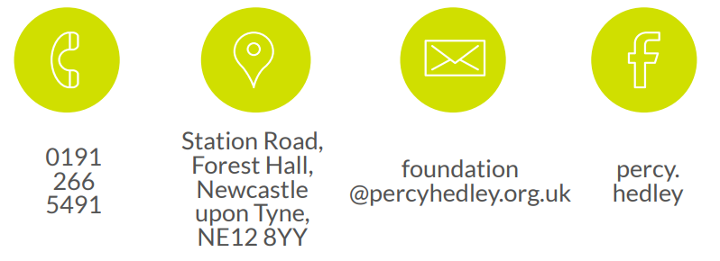
We are committed to safeguarding and promoting the welfare of children, young people and vulnerable adults. Applicants should be aware that the post will only be offered to successful candidates subject to an Enhanced DBS check as well as other employment clearances.

