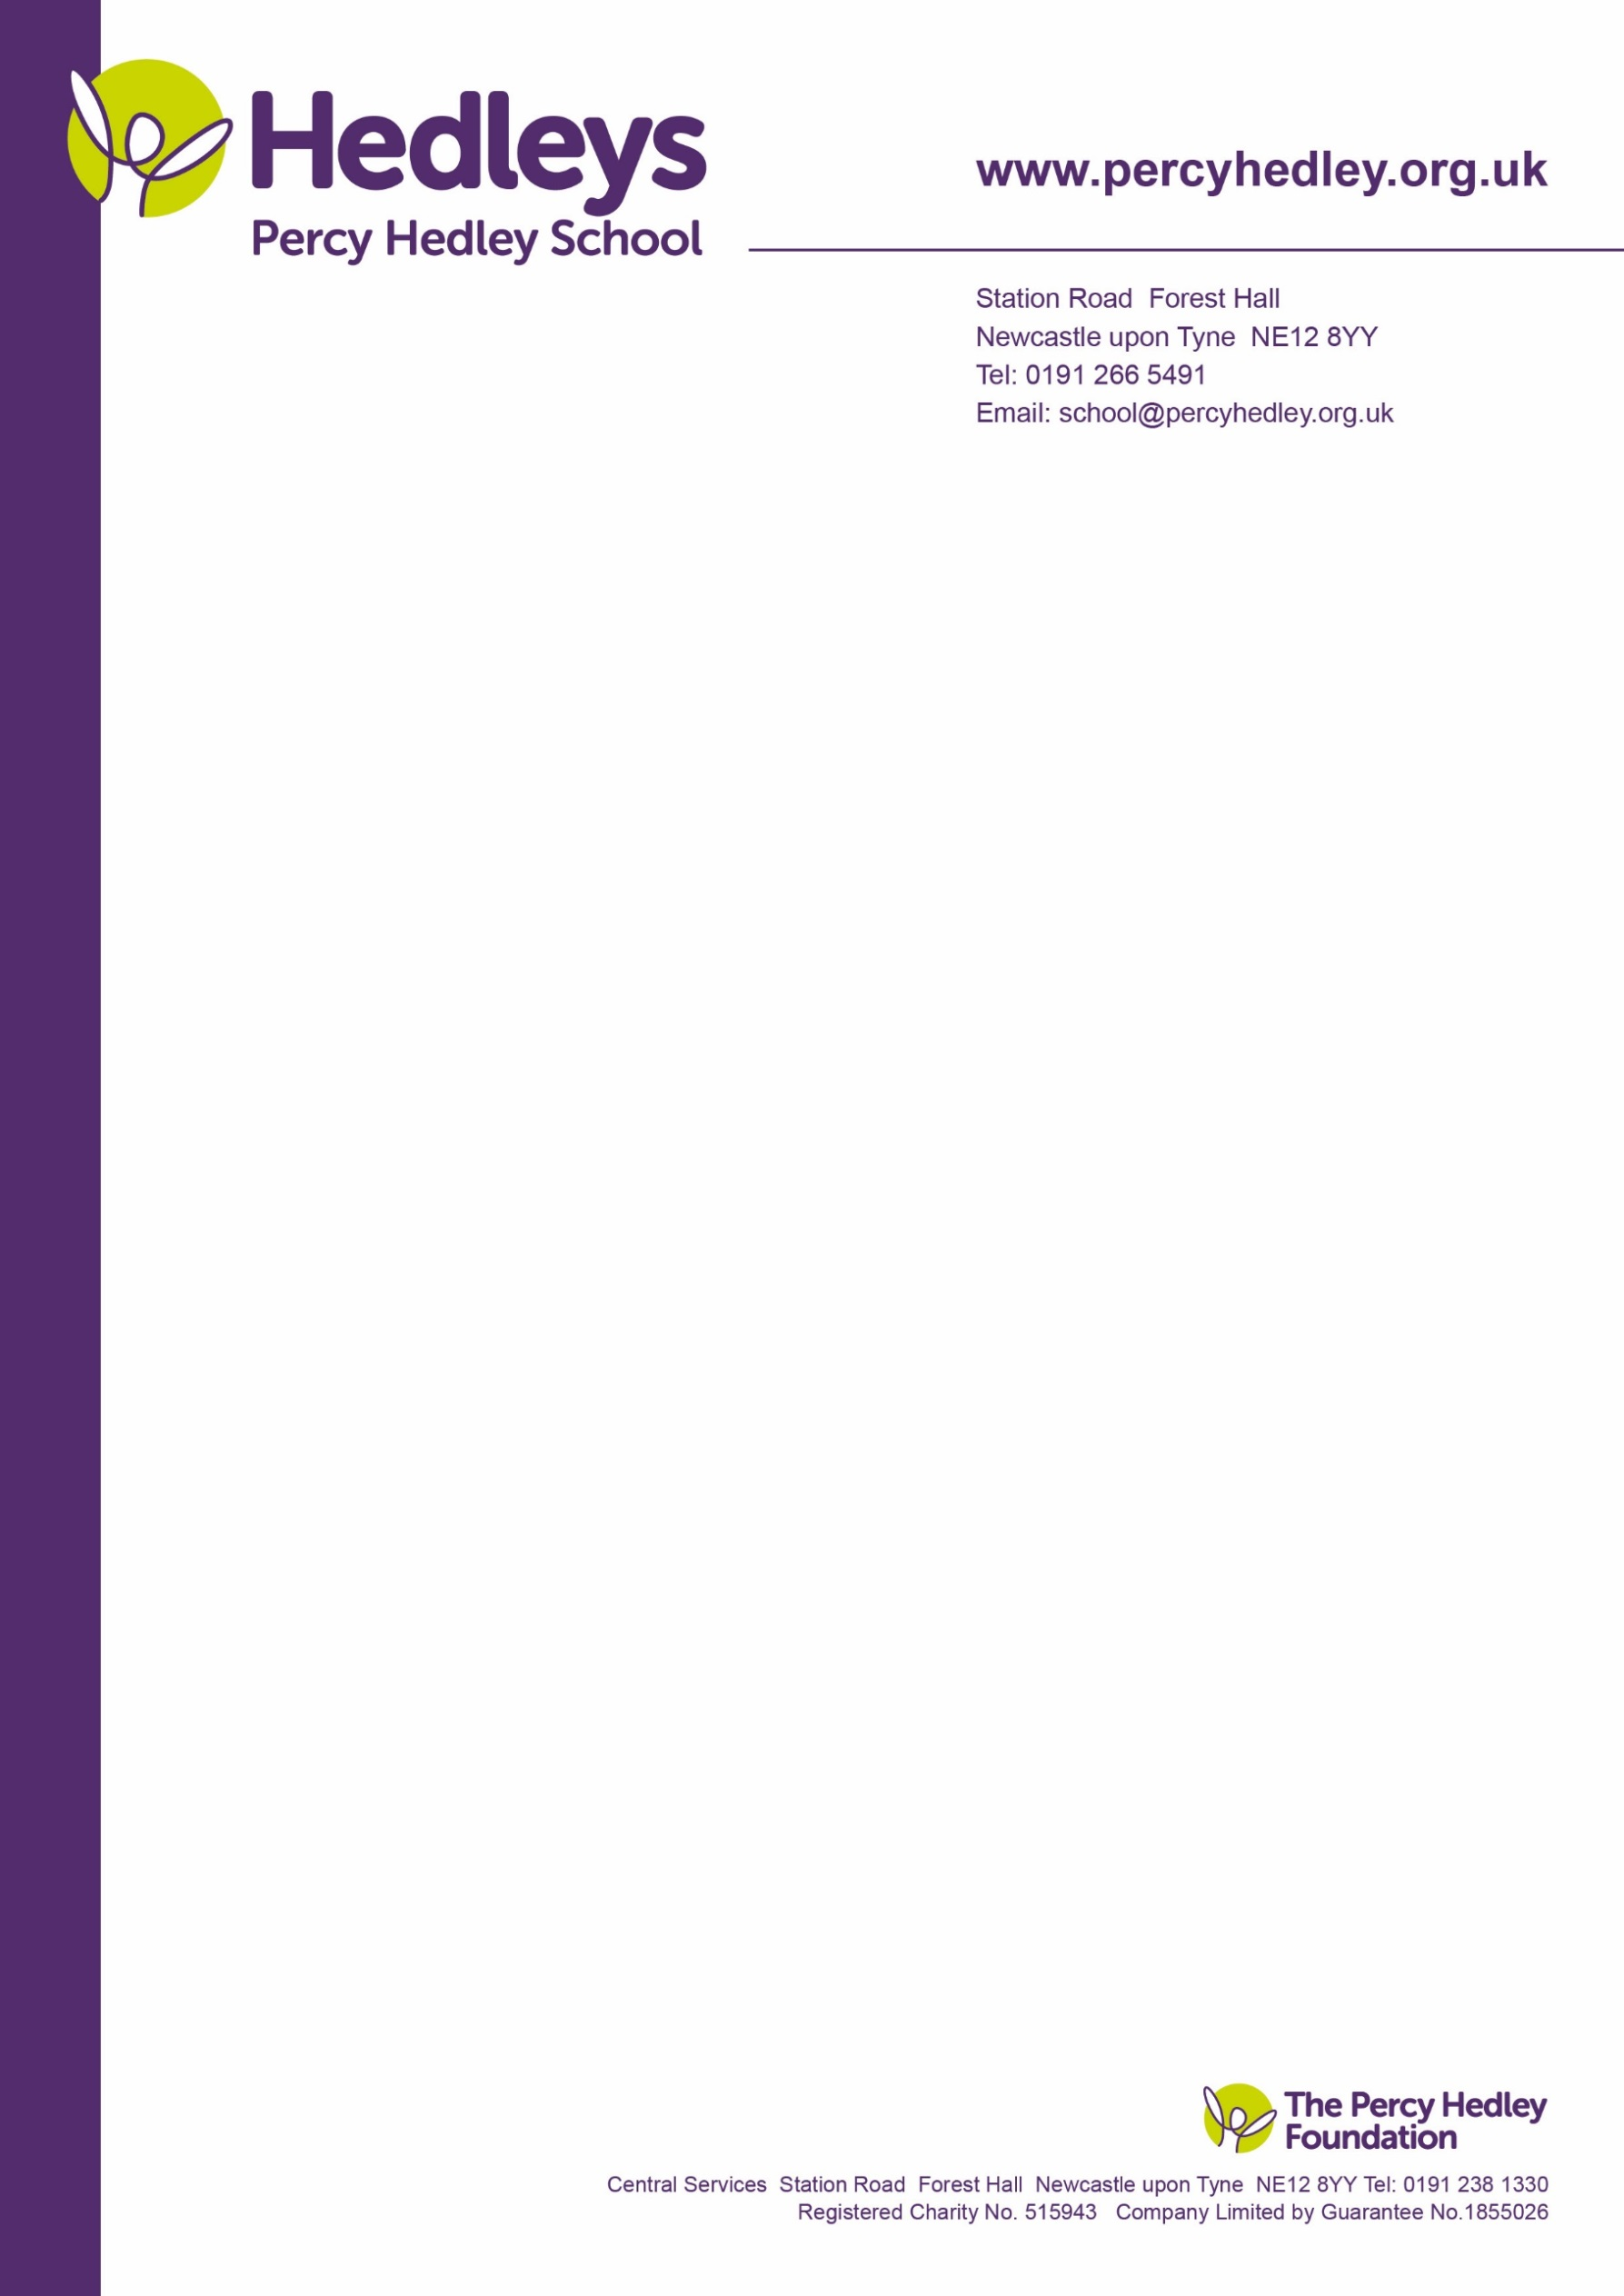

**Whole School Curriculum Overview**

September 2024

Percy Hedley School is an all-age school for children and young people with a wide range of special educational needs & disabilities. We provide an ambitious, broad, rich, deep and aspirational curriculum at levels appropriate to the developmental understanding of our pupils. The curriculum is underpinned by the school’s Key Drivers: Communication, Wellbeing and Independence

Our curriculum is designed to help our pupils to become

* Successful learners who are engaged in and enjoy their learning – making excellent progress and experiencing achievement
* Effective communicators who can express themselves, make choices and build positive relationships with other people and have increasing control and influence over their lives
* Confident individuals who having had a variety of successful experiences are able to take a full part in activities within school and the community. Also, to provide the appropriate level of challenge and risk taking to develop the resilience and aptitude to be able to cope when things go wrong
* Active participants in developing a healthy, safe lifestyle, developing good relationships and respecting differences between people, developing positive mental and physical health, happiness and a sense of wellbeing
* Well-prepared for their adult life where they have increasing control and influence over their own lives and develop into citizens who are as independent as possible

Whilst the overall aims of the curriculum will be the same for all children and young people attending Percy Hedley School, the styles of teaching and learning may be different according to the specific learning needs of the pupils

The curriculum is highly personalised as each pupil has planned progressive steps in learning and individual targets based on their assessed previous skills and knowledge rather than for their age or year group. Due to the particular needs of an individual pupil, some may not have an ‘even profile of ability’ across the curriculum and consequently rigorous assessment is key to identifying progressive steps in learning across the curriculum. The curriculum provides the opportunity for pupils to access broad and balanced learning at a differentiated level meeting statutory requirement

Our curriculum, both in terms of the pathways and subjects, supports safeguarding whilst ensuring progress, and operates under the premise that they are essentially the same entity when we consider our ultimate aim, our mission, which is for our learners to have happy, fulfilling lives as active and included citizens or our society, while they are with us and beyond; that they are well-prepared for adulthood, society and the world

**Curriculum Approach**

PHS has ambition for all children and young people and as such we strive to provide a meaningful, aspirational curriculum which is a framework for learning that we deliver through a spiral approach

The school’s pedagogy involves this spiral approach where year-on-year knowledge and skills are revisited and built on to provide depth as learners master skills and apply these in functional situations. We base our approach on optimising pupil motivation to learn. Within this we acknowledge that progression is not necessarily about movement up a ladder of knowledge and skills. Lateral progression is important in being able to master the knowledge and skills that have been learned such as to different contexts, situations, with less scaffolding and support, with different people and in different environments. Retention of fundamental knowledge and skills which embed into the long-term memory is important - to know more, do more and remember more

This approach has three key principles

* Planning is cyclical - pupils return to topics throughout their time in school
* Increasing depth is planned each time a topic/theme/program is revisited towards a mastery level
* Prior knowledge is utilised when a topic is revisited so pupils build upon a strong foundation

**PHS has mapped curriculum provision by**

* Providing this overview of the work we have planned in school, including our intentions, implementation, of the specific areas of the curriculum, and the expected impact
* Developing four specific curriculum pathways including Early Years (Explorers & Adventurers), Pre-formal to Informal (Learning Skills Through Engagement), Semi-formal to Formal (ELTBA) and Formal (Appropriate Accreditation). These pathways are not fixed for pupils, and pupils can and do move between them as appropriate and as indicated through robust assessment
* Collating overviews for each subject so teachers know what they are teaching and when
* Written progression documentation to ensure a sequential approach
* Teachers develop and deliver the curriculum through a topic/thematic approach or through planned programs of work, utilised dependent upon the age and needs of learners. Topics/Themes are mapped across each term and identified skills and knowledge are identified to ensure breadth in learning
* Ensuring pupils’ progress through their curriculum is tracked and shared to ensure all further learning is sequential and builds upon prior knowledge and skills attained
* Teachers explicitly include safeguarding in their planning and clearly record where and when they deliver particular aspects of safeguarding. This means that safeguarding is embedded in our curriculum, and that our curriculum promotes safety in all its forms

**Cultural capital – What does this mean at Percy Hedley School?**

Every child and family who joins our setting will have their own knowledge and experiences that will link to their culture and wider family. This might include: languages, beliefs, traditions, cultural and family heritage, interests, travel and work

Cultural capital is the accumulation of knowledge, behaviours, and skills that a child can draw upon and which demonstrates their cultural awareness, knowledge and competence; it is one of the key ingredients a pupil will draw upon to be successful in society, their career and the world of work. Cultural capital gives power. It helps children achieve goals, become successful, and rise up the social ladder without necessarily having wealth or financial capital. Cultural capital is having assets that give children the desire to aspire and achieve social mobility whatever their starting point.

Our understanding of ‘knowledge and cultural capital’ is derived from the following wording in the national curriculum: *‘It is the essential knowledge that pupils need to be educated citizens, introducing them to the best that has been thought and said and helping to engender an appreciation of human creativity and achievement’.*

At PHS, children benefit from a curriculum that builds on what they understand and know already.  Through our Curriculum Design, their experiences revolve around the coherent cycle of learning from the past, living in the present and looking to the future.  This means our children have a deep and connected knowledge and understanding of where they came from, who they are and what they might become. We believe that exposure, not only to culture but also to situations in which the children might not have previous experiences of, is of paramount importance to their ongoing successes

Gradually widening children’s experiences as they progress through our school is an important step in providing rich and engaging learning across the curriculum to ensure that those children become productive members of society

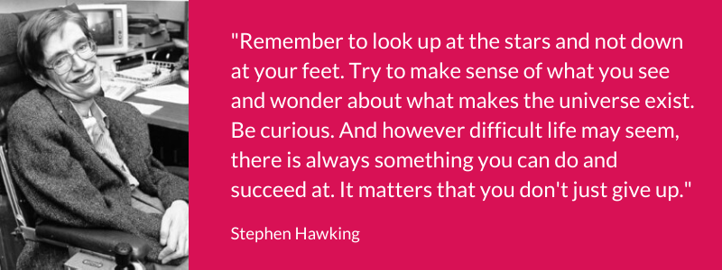



**Curriculum Pathways at Percy Hedley School**

We have four curriculum pathways

* Early Years – Explorers & Adventurers
* Pre-formal to Informal – Learning Skills Through Engagement
* Semi-formal to Formal – Experiential Language Topic Based Approach (ELTBA)
* Formal – Appropriate Accreditation

To ensure the curriculum pathway and class group are well matched to the pupil’s needs several influencing factors are considered when determining the most appropriate curriculum pathway and class group. These include the cognitive stage, age, and social & emotional needs of our pupils. Pupils are re-grouped every September, or earlier if required, based on assessment and teachers’ knowledge and understanding of the pupils; this ensures the most appropriate class groups are formed and allows the curriculum to be delivered most effectively to pupils with similar profiles

**Early Years (Explorers & Adventurers - EYs to Key Stage 1)**

* The Early Years curriculum is designed with the following principles in mind. At PHS we value each child as an individual and strive for an education that develops the child holistically. We believe that an effective curriculum tailored to suit individual needs, increases children’s engagement, knowledge, skills, and understanding and maximises learning outcomes
* The Early Years Curriculum offers children a personalised approach which is reflective of the child’s age and stage of development, enabling opportunities that support them to work towards early learning intentions, through structured sessions, sensory and play-based experiences
* Through our individualised approach, we strive to ensure that we are meeting every child’s needs, enabling them to actively participate in learning experiences and optimise their development and learning potential.  We put the children at the forefront of everything we do and ensure that children receive a curriculum that is ambitious, inspiring, engaging, and exciting, allowing them to learn, grow and flourish
* The children are taught through a combination of adult-led, child-led and enhanced provision activities, allowing them to display curiosity within their environment, explore new concepts, follow their own interests, and increase independence



**Pre-formal to Informal (Engagement – Key Stage 1 to Key Stage 5)**

* Learners may have profound and complex needs, a severe learning difficulty and/or medical condition, sensory impairment, profound barriers to learning and/or physical disability. They will be learning at an early developmental stage and will require a high level of adult support to meet their educational and personal care needs; often 1:1
* Young people become secure in their environment in a way that is meaningful and purposeful to them. The focus is upon enabling them to establish positive interactive relationships with others, to proactively explore the world around them and to gain environmental control skills. All pupils will be given maximum opportunities to achieve the highest level of independence possible
* Pupils do not access subject specific learning within the Learning Skills Through Engagement Pathway, as appropriate for their stage of learning. Pupils follow a curriculum which focuses on the pre-requisite skills and exposure to knowledge required to further learning in readiness, if applicable, for progression on to a semi-formal curriculum pathway
* While many children within the Learning Skills Through Engagement Pathway remain within the same pathway for the duration of their time in school, those children who demonstrate their readiness for subject specific learning move on to a semi-formal pathway as their curriculum needs change. Those remaining on the Learning Skills Through Engagement pathway as they transition into Key Stage 4 begin to access Awards in recognition of their achievements. There is continued focus on independence and preparation for adulthood as pupils move through to Key Stage 5
* The curriculum is mapped to include an overlap on to the semi-formal curriculum to ensure a continuous transition between curriculum pathways where appropriate
* On-going assessment indicates whether a change of curriculum pathway is appropriate
* Pupils’ progress through their curriculum is tracked and shared as they progress through school ensuring skills and knowledge are revisited and built upon appropriately as indicated through the Pupil Passport

**Semi-formal (ELTBA – Key Stage 1 to Key Stage 3 - Willow Route)**

* These learners will have significant learning difficulties/disability and/or physical disabilities. They may have difficulties with sensory processing, communication and self-help skills. These learners are likely to need additional support to access all aspects of the curriculum
* Pupils will learn most effectively when what they are learning about is tangible and real to them. They will learn best when learning is related to their own experience. Structured play, topic-based work and a focus on generalising their knowledge, skills and understanding is important
* Pupils access subject specific learning through a topic-based approach at a pre-National Curriculum stage
* Many pupils have an uneven profile with particular areas of splinter skills and knowledge. An individualised ambitious curriculum, where learning can be targeted at the appropriate stage is necessary to ensure pupils achieve to their potential

**Semi-formal to Formal (ELTBA – Key Stage 1 to Yr 8 - Cedar, Hazel, Pine Routes)**

* These learners access a range of National Curriculum subjects modified for their developmental stage. The teaching sessions are more ‘formal’ and are taught in a structured way drawing upon pupils’ speaking, listening and communication skills
* While still needing a high degree of practical and functional-based work these pupils can learn about more abstract concepts seen through a National Curriculum ‘lens’
* Life skills and independence skills will also form a large part of the curriculum. A high level of structure and first-hand experience is required to achieve success
* Teachers ensure that learning is linked to practical activities and consolidated and applied in practical sessions
* Our curriculum intends to respect and reflect the National Curriculum in its entirety and is contextualised to our unique school community

**Formal (Appropriate Accreditation – Yr 9 to Key Stage 5 - Willow, Cedar, Hazel, Pine, Maple, Oak Routes)**

* Pupils assessed stage at Yr 9 indicate the appropriate curriculum route that they will follow in the Appropriate Accreditation pathway. These routes are not set; ongoing assessment indicates whether the pupil requires an alternative curriculum route and subsequent accreditation as the pupil progresses
* There are a number of routes available ranging from Willow (Informal Awards and Life Skills), Cedar (Entry Level 1), Hazel (Entry Level 2), Pine (Entry Level 3), Maple (Level 1), Oak (Level 2/GCSE)
* Pupils prior learning and acquisition of knowledge and skills is tracked and shared through the Pupil Passport ensuring the transition from lower to upper school continues to work upon the sequence of knowledge and skills as mapped

**Preparation for Adulthood**

* In line with our school’s Key Drivers, the importance of independence is recognised and prioritised. A focus on independence begins at the very earliest stages of a pupil’s learning journey at PHS and continues throughout their school career as they prepare for adulthood and their next steps
* Independence/Preparation for Adulthood varies in its nature across the four curriculum pathways and is specific to the individual needs of the child/young person
* For our youngest cohorts (up to Yr 7) the pupil’s readiness for school, early steps towards independence regarding self-care tasks and steps towards independent learning, as appropriate, forms the focus
* As children move into Yr 7 and beyond preparation for adulthood becomes more fomalised and includes: focused employability sessions, careers guidance (CEIAG), impartial careers and transitions advice from Connexions within North Tyneside Council and widening experiences/encounters
* From Yr 9, where appropriate, pupils have explicit weekly Employability sessions, and their progress is tracked through PfA outcomes. Additional support is given through impartial careers interviews, college visits and work experience opportunities as appropriate. Other options such as an Outdoor Learning award and the life skills curriculum also enhance and personalise student experiences alongside their options choices within post-16. PfA at PHS is designed to meet the individual needs of all the learners and is reviewed regularly to match pupils’ needs, strengths, and interests
* The four areas in Preparation for Adulthood, education and employment, independent living, community inclusion and good health and emotional wellbeing are a particular focus for all pupils within PfA
* Independence/PfA seeks to achieve coherent progression alongside the four pathways in school, and centres on pupil views and personal choices, which are reflected in the curriculum, targets and personalised timetables
* Our aim is to provide all our learners with a range of qualifications and skills that meet their different needs, reflect their interests and prepare them for adult life, their next steps and lifelong learning
* As pupils approach the end of their time at PHS they can be involved in their transition planning; this includes impartial college and/or social care visits to enable pupils and families to make informed decisions about their future

**Curriculum Overview**

PHS provides an ambitious curriculum designed to equip all children and young people with sufficient skills, knowledge and experiences - Cultural Capital - to function within daily life with optimal independence, health & wellbeing, and the ability to communicate to their optimal level in order to make choices, enjoy positive relationships and remain safe

Through an in-depth understanding of each child’s needs (cognition & learning; communication & interaction; social & emotional mental health and physical & sensory), we set personalised and ambitious learning outcomes as the foundation for tailor-made curricula activities

Our intention is for the curriculum to provide ambitious stretch and progression for all learners with an understanding that each child is on their own bespoke journey and will progress at a different rate and trajectory. We are determined to ensure the same inclusive ambition for all pupils regardless of background or starting point

**Assessment**

To meet the needs of a range of pupils with complex needs, there are a number of assessment systems in place to monitor and analyse pupil progress from their individual starting points

A holistic view is taken to track progress of our pupils. This can be demonstrated through achievements in the following areas as captured through ‘The Wheel’ – a holistic and inclusive system for summatively measuring pupil progress in the following areas

* Attendance
* Therapy
* EHC Outcomes
* Curriculum Pathways
* Wellbeing
* Case Studies
* Key Drivers including parental feedback
* Behaviour for Learning
* Destinations & Next Steps

Assessment data is used to inform future planning and to indicate any necessary interventions for those pupils who may not have made expected progress

Within the four curriculum pathways, specific assessment criteria are used to track and monitor progress of pupils dependent on the pathway they follow

**Engagement**

* The pre-formal to informal curriculum forms a strong foundation for learning, built upon a pedagogy where real understanding is assessed before pupils advance to a semi-formal curriculum, if appropriate
* On-going assessment and tracking ensure pupils continue to build on skills and exposure to the necessary knowledge required for further learning
* Pupil Passports containing curriculum coverage and pupils’ assessed stages against the ‘Assessment for All’ framework ensure all transitions across school are fully supported and learning is sequenced appropriately. The necessary information ‘travels’ with the pupil across their learning journey throughout their time at PHS and is updated regularly to ensure it provides an accurate reflection of the pupil’s learning journey to date

**ELTBA**

* The semi-formal curriculum at Phase 5-8 (Willow), follows pre-National Curriculum expectations. This allows pupils to build the prerequisite knowledge and skills needed to access National Curriculum learning through the achievable steps of the Phase 9 - 11 Cedar curriculum and beyond. Highly effective transition through the use of Pupil Passports ensures continued progression
* In the semi-formal to formal curriculum we aim for pupils to transition to a more formal approach (in a specific subject area or whole curriculum) through Phase 9 -15 (Cedar – Pine) where pupils access a content which is rich in the knowledge and skills required for further learning. This prepares pupils with the appropriate knowledge and skills for their continued learning journey into upper school during their Yr 9 transition year. Again, Pupil Passports indicating curriculum coverage and assessed stages of learning ensure pupils are prepared well for future learning. Knowledge and skills that pupils have acquired to date are further build upon through the most appropriate route from Yr 9 onwards as pupils transition to the Appropriate Accreditation pathway

**Appropriate Accreditation**

* In the formal Appropriate Accreditation pathway, pupils access a number of curriculum routes dependent on their assessed stage. This prepares pupils to access appropriate accreditations
* The pupil’s assessed attainment level at Yr 9 indicates the most appropriate route. This is not set and pupils can progress to alternative routes depending on their progress
* Pupil Passports indicating curriculum coverage and assessed stages against accreditation criteria ensure pupils are prepared well for future learning and the knowledge and skills that pupils have acquired to date are further built on through the most appropriate route

At all points in a pupil’s curriculum journey PHS has a highly ambitious approach to optimise pupils’ ability to learn, apply skills and knowledge in functional situations. This epitomises our ambitious approach to learners’ developing their full potential

**Impact of Percy Hedley’s approach to the curriculum**

The aspiration for all pupils who attend Percy Hedley School is that they achieve their potential in all aspects of their development. The outcome of the curriculum is highly individual. All achievement and progress are celebrated

All our 2024 leaving cohort have moved on to their 1st choice destination. This is indicative of the ambition we hold for our pupils

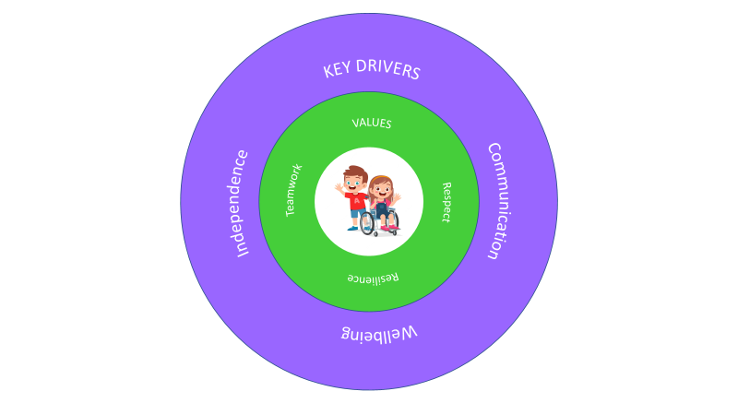

**PHS Senior Leadership Team & Governors, September 2024**