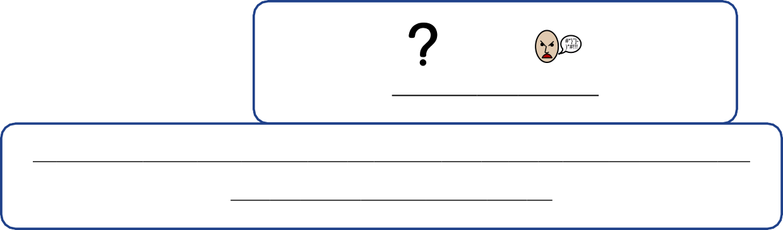

**What is abuse?**

**If someone hurts you, upsets you or causes you to be in pain on purpose this**

**can be called abuse. Abuse can be:**

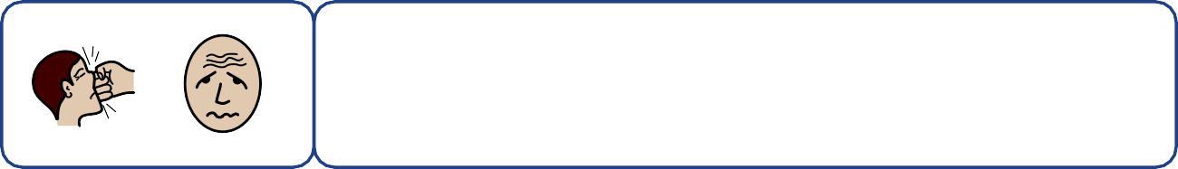

If someone hits you, makes fun of you or makes you feel nervous, worried or sad on purpose.

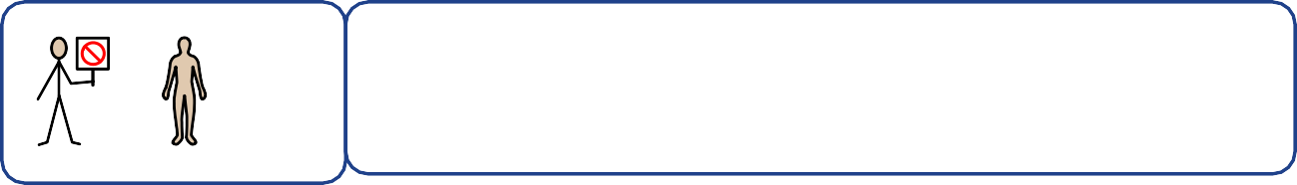

If someone touches you in a private place.

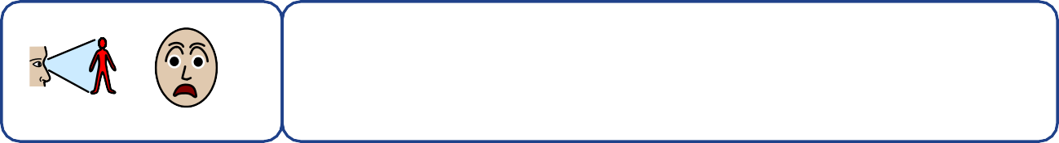

If someone makes you look at things and it makes you feel worried or uncomfortable.



If someone asks you to do something you know is

wrong.

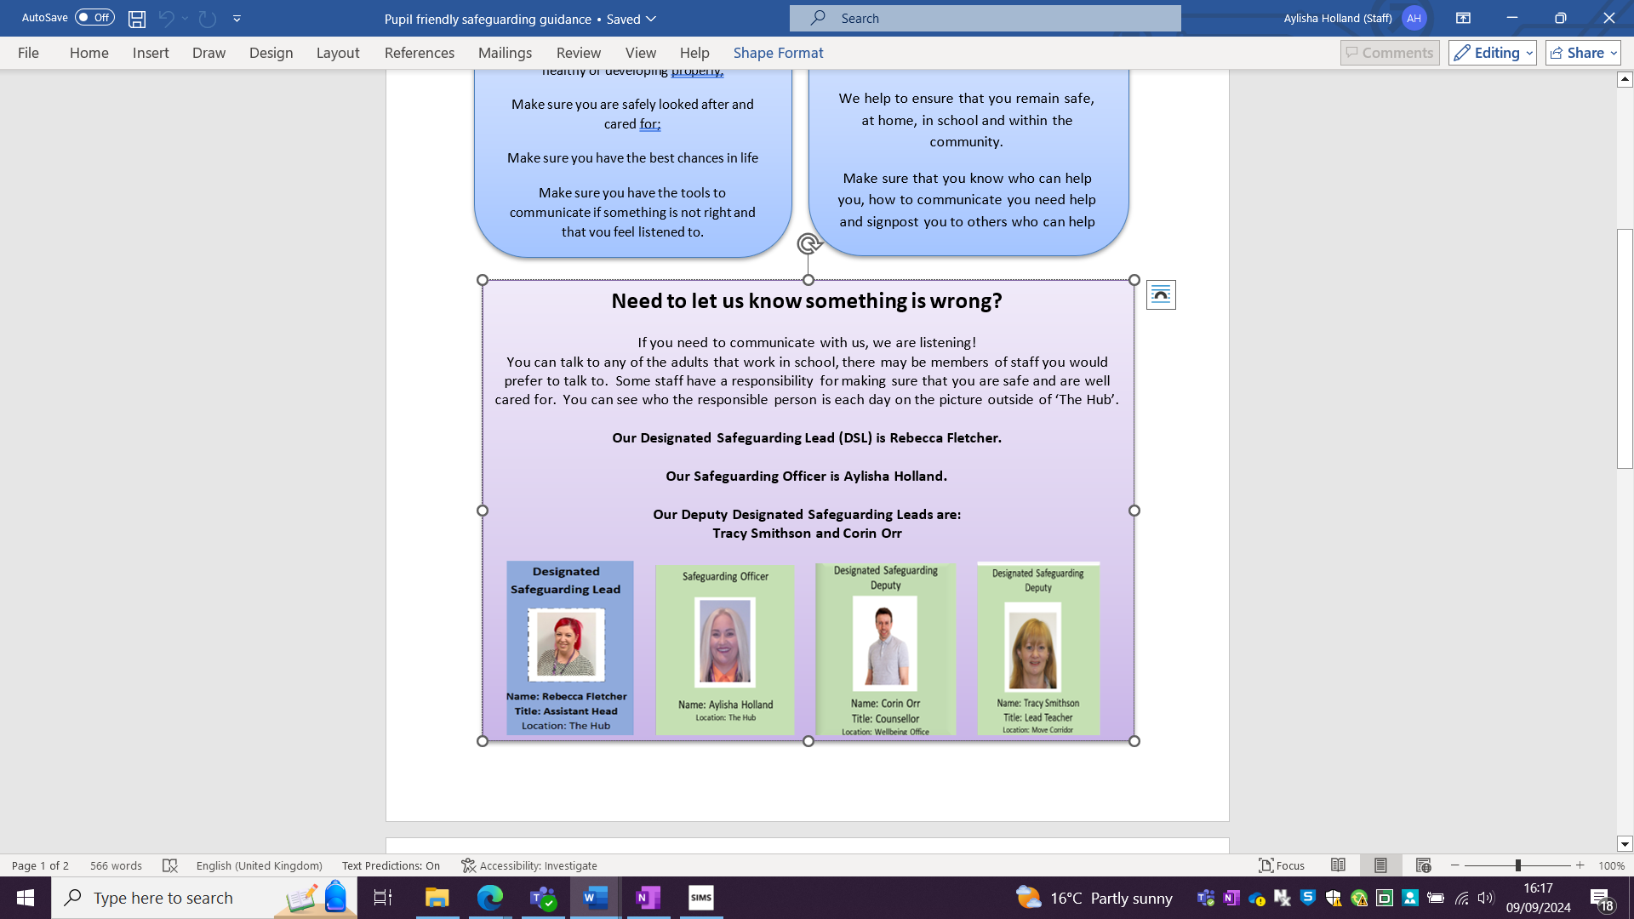

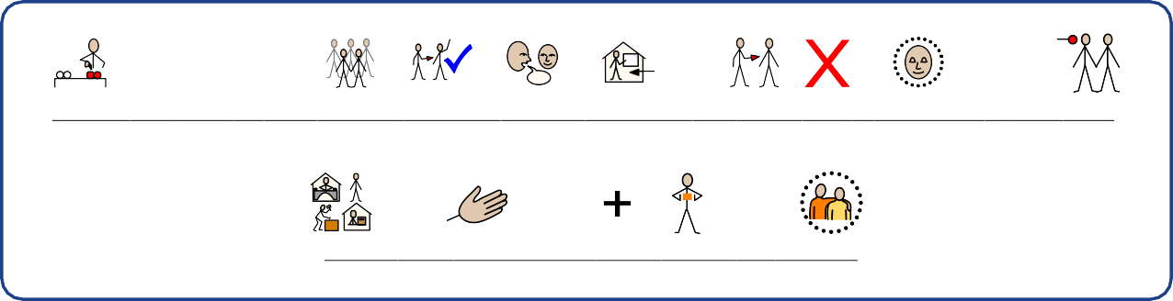

**These are some of the people you can talk to in school if you don't feel safe. It is their**

**job to help you and keep you safe.**



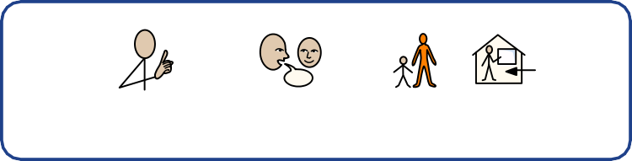

**It is important to tell an adult in school if...**

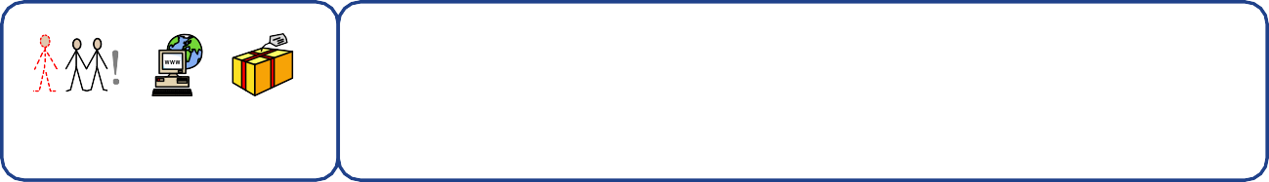

If a stranger tries to buys you presents or gives you special jobs to do.

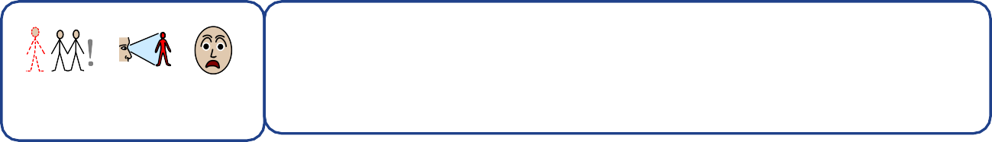

If a stranger talks to you online and tries to be your friend.

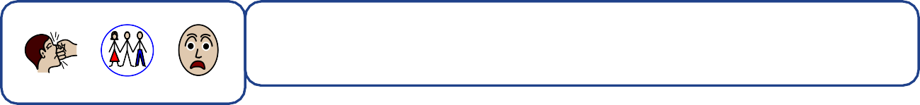

Someone hurts, shouts or hits someone you live with.

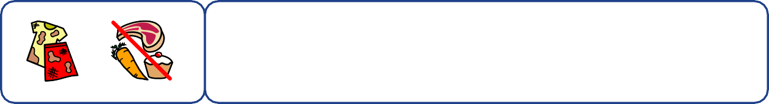

If you or your clothes are dirty, you don't have enough food at home or you cannot get to school every day.

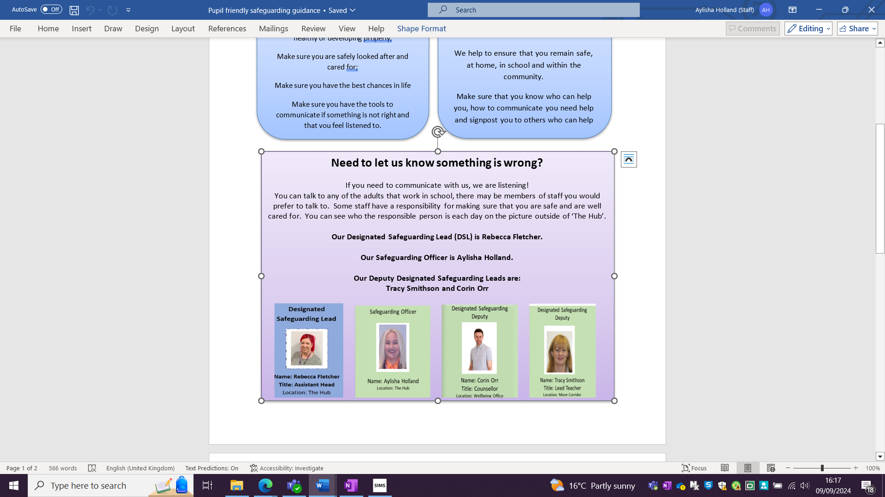

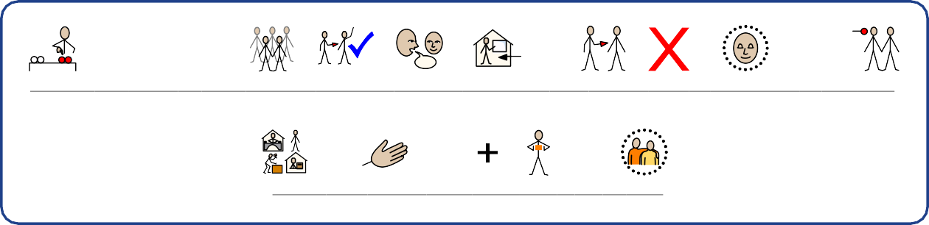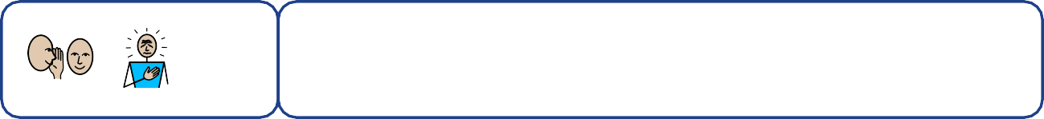

If someone asks you to keep a secret that you don't feel good about.

**These are some of the people you can talk to in school if you don't feel safe. It is their**

**job to help you and keep you safe.**