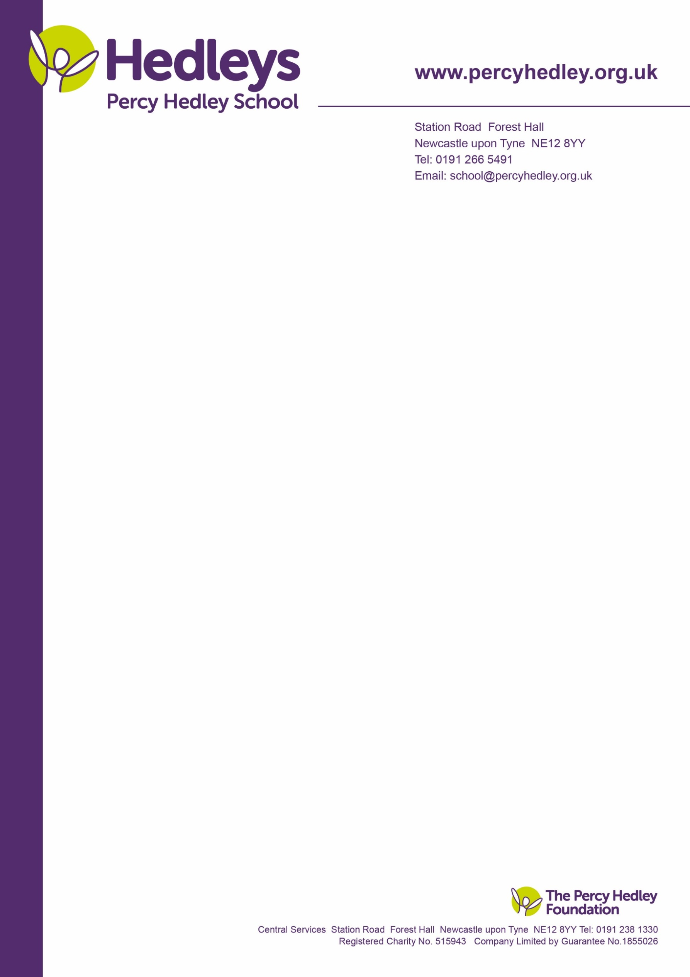
Dear Parent/Carer,
As we approach the end of the Spring term, we are writing to update on some of the contextual safeguarding concerns nationally and within our local area.
Challenges young people are facing around sexuality and gender identity.
An important part of growing up for young people is understanding their identity, working out who they are, who they want to be and how they want to be seen by others. For some young people this includes exploring their sexuality (who they feel attracted to) or gender identity (how they feel about their gender).
Using insights from Childline counselling sessions and NSPCC Helpline contacts from 2022/23, NSPCC Learning has put together a briefing about the challenges young people and children face regarding their sexual and gender identity.
In 2022/23, Childline delivered over 195,000 counselling sessions. In just under 3,400 of these, children and young people wanted to talk to counsellors about their worries about sexuality or gender identity. During the same period, the NSPCC Helpline handled almost 60,000 contacts from adults concerned about a child’s welfare. Less than 1% of these contacts (46) were about a child’s sexuality or gender.
Some young people face pressures or challenges with these issues. Key themes include:
- Coming out to the family
- Conversation practices
- Pressures in school
- Pressure to choose a label
- Young people struggling with guilt and self-acceptance
Key finding within the briefing from NSPCC Learning include that some children and young people:
- Felt their decision about their sexuality or gender were dismissed by the adults in their lives.
- Mentioned emotional abuse in the family home, including constant shouting, hurtful comments, and threats of violence.
- Felt pressured to conform to gender stereotypes in school

More information about this can be found at: https://learning.nspcc.org.uk/research-resources/2024/challenges-young-people-are-facing-around-sexuality-and-gender-identity

West Lane, Killingworth
Newcastle upon Tyne, NE12 7BH
Tel: 0191 216 1811
Email: school@percyhedley.org.uk

The Sam Fender affect
Local singer/song writer Sam Fender has reflected on his challenges straddling the line between adolescence and adulthood on his track ‘Seventeen Going Under’. The lyrics talk about anti-social behaviour on the beach. Due to this we receive alerts to school about issues on the beaches and expected gatherings. Our pupils are at increased vulnerability with these issues and therefore it is important that our parents are aware of these issues.
Our local coastlines can attract a range of ages, however it important to note that our local Neighbourhood Policing Teams actively address instances of anti-social behaviour at local beaches. Support with water safety can be found on the RNLI website Water Safety Advice And Tips - Know The Risks (rnli.org)
Child Financial Exploitation
More and more children are becoming victims of criminal exploitation with the lure of easy money. We might not immediately think of children when we hear the words ‘financial fraud’. But the reality is that more and more young people are being groomed into fraudulent things like opening bank accounts for criminals. Children and young people are often unaware of the risks and are abandoned to face the consequences while criminals continue to exploit others. Online safety for our children and young people is imperative as the rising trend of young people being groomed online through social media and online gaming platforms to participate in criminal activity such as money laundering. Criminals offer gifts, promise easy money, gaming credits, skins or cryptocurrency. This is child financial exploitation. For further information visit Children Forced Into Opening Criminal Bank Accounts | The Children's Society (childrenssociety.org.uk)

We hope you found the information in this update useful as we continue to work together to ensure all the pupils within our care are safe and secure. Should you, or your child ever have any safeguarding queries please do not hesitate to contact the school. Please also find a wealth of information about all areas of safeguarding on our Safeguarding page on our school website.
As always if you have any safeguarding issues over the holidays a member of the safeguarding team is available to talk to. Aylisha Holland our safeguarding officer is your designated contact for the Easter Holidays and can be contacted at: aylisha.holland@percyhedley.org.uk
Yours sincerely
The Designated Safeguarding Lead Team at PHS

