Find out more about our Governors:

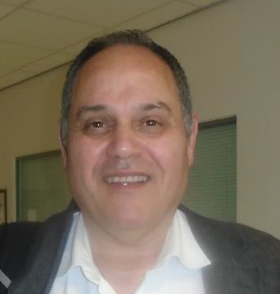
Tom Cosh: Acting Chair of Governors/ Health and Safety

Hello, my name is Tom Cosh
I am a co-opted governor, who started volunteering at school as a Parent Governor. I have 10 years of service as a member of Percy Hedley Board of Governors and am currently the Vice-Chair. I live in Morpeth with my adult son and wife. Over April 2022-23, I had the privilege of acting
up as Chair of Governors during the period the post was vacant. I look forward to working closely with the new Chair, Allan Lacey. In the recent past my governor service included supporting the newly appointed Head Teacher; engaging with and monitoring major whole school curriculum change; participating in OFSTED inspections of the school and chairing an official Complaints Panel. My motivation in being a governor is twofold. First, I want to give something back to this wonderful institution for helping my family. My son attended junior and senior school here and now volunteers at PHS 3 days a week - the school is a positive force in his and our lives. Secondly, my professional skills can be used to support the school’s development. These were developed working in international management consultancy in education for Brunel University, as the Head of Service at Newcastle City Council, as an interim manager tasked with organisational change for Capita and now as a University module leader. I am currently writing up my Doctorate in Education at Newcastle University while teaching economics to international students, so they can successfully enter year 2 at NU Business School.
I have no business links to Percy Hedley School.

Paul Cook: Safeguarding including Attendance
Hello, my name is Paul Cook. I have been a co-opted governor at Percy Hedley school for almost 2 years and have a special responsibility for safeguarding.
I have experience in the safeguarding field as I was a child-care social work practitioner and manager in local
government through much of my working life. I have not worked full time since 2014 although since this time I’ve continued with my interest in fostering and adoption matters through chairing a panel. I’ve used my social work experience to do some social care complaints and a few specialist reports for tribunals and family court.
Being a governor has been a useful way to make a contribution to a local school, as I live nearby and Is a good way to re-cycle my knowledge/experience of safeguarding. I’m involved too with a local charity that works with young people and assists them into employment through providing training in motor mechanics I occasionally get out on a bike to ride a few miles although nowadays I’m probably mostly a fair weather cyclist and more interested in the coffee stops.
I’ve enjoyed my time at Percy Hedley; getting to have a deeper knowledge of the school and the staff. It’s an interesting set up and I like its commitment t to the children and their parents.

Kate Hellens: Parent Governor/ Literacy and Reading

Hello, my name is am Kate Hellens,
I am privileged to be a Parent Governor of the Percy Hedley School. My son who has spastic cerebral palsy has attended Percy Hedley for 9 years and has enjoyed every moment. (Well maybe not the Maths!) I am a link governor
for the Literacy Programme and regularly visit in school to meet with teachers and other staff to discuss the programme and how it can be developed further. Due to my background in construction and social housing I also have an excellent link with the estates team and all the amazing work they plan for the school site. I help ensure that the governing body forges strong links with the PTA and Family liaison officer in school, with school – parent communication being so critical to the success of the Percy Hedley community. I am thoroughly enjoying being more involved with the school, giving me an insight into the challenges and responsibilities that the organisation faces as well as an opportunity to give back to an organisation which has helped me and my family so much.

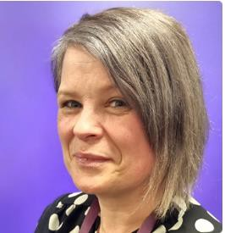
Claire Hayden: Teacher/ SMSC, British Values, CIT & RE Hello, my name is Claire Hayden and I am very proud to have obtained and held the role of staff governor at Percy Hedley
School for over 8 years. I have been a teacher here since 2013 and during this time, I have thoroughly enjoyed teaching across
Key Stage 2, 3, 4 and Post 16. I worked for six years with students with complex
needs before returning to my specialism in working with students with speech and language difficulties e.g. Autism, ADHD. I am currently a member of the middle leadership team and the lead teacher for upper School- Key Stage 4.
I strongly believe in supporting our pupils in achieving their best possible
outcomes and therefore became a qualified Positive Behaviour Support coach and a member of the school safeguarding team.
I am an advocate for stakeholder involvement and have been strongly involved with pupil voice, the school council and the PTA (now known as the friends of PHS). I feel passionate about creating and facilitating memorable learning.
experiences for pupils and often organise or support whole school events and enrichment opportunities.

John Steward: Headteacher

I'm the Headteacher of the school and have been substantively since September 2021; it's great to be here. I've worked in lots of different kinds of special schools around the country and been a Headteacher and similar a few times too.

It's a real pleasure to be Head of Percy Hedley School and work with parents & carers for the children of all ages we have here. The school is unique in its therapy provision, which was one of the things that attracted me. Mixed teams of professionals all working together is what our children need, and we work hard to provide that here. I hope you find what you're looking for in a school and if we can help in any way, we will. All the best, John S

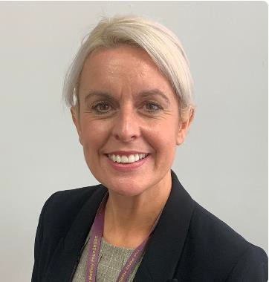
Carla Maley: Non-Teaching School Staff/ School Business Manager

Hi, my name is Carla Maley, and I am the School Business Manager at Percy Hedley School.
I have worked at Percy Hedley School since 2012 and have been on the governing board as the non-teaching representative since February 2022.
My background prior to Percy Hedley was working within the private business section, which I feel gives a broad spectrum of skills and knowledge to effectively manage the strategic and operational functions of the school.
Outside of work, I am a mum to three boys, and a keen runner – I like to be busy! I love to travel and particularly love visiting the Lake District and South of France.
One of my reasons for becoming a staff governor is to have a voice and to represent the perspectives of the staff members in the decision-making process. I take great pride in working at Percy Hedley School and by being an active part in the governance process as well as with my first-hand experience and insights into the day-to-day operations of the school, I feel I can help shape policies and initiatives, which will ultimately enhance the learning environment and overall effectiveness of the school.

Ross Holden: Parent Governor / Therapy and Physical Development

Hello, my name is Ros Holden and I have been a parent governor at Percy Hedley School since early 2022. My daughter as a rare genetic condition, known as Xia-Gibbs syndrome, and has been on the Engagement Pathway at Percy Hedley School since joining the school in 2019. She loves coming to school and has a great bond with all the staff who work with her. I volunteered to be a governor so that I could use my skills in a way that would be beneficial to the school and give something back. I don’t come from an educational background but I am a chartered accountant and have experience of governance processes and accessing risks.
My link governor roles are Therapy and Physical Development, so I regularly visit the school and engage with the therapy staff.
Observing the transdisciplinary approach across lessons and how therapy is woven into all tasks has been really insightful.
I am also an active member of the Friends of Percy Hedley School (FoPHS) and have been Treasurer for a number of years.

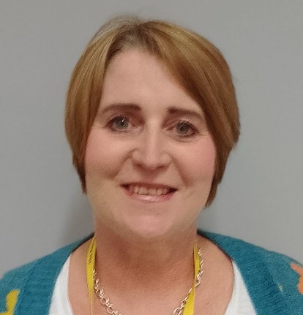
Julie Dick: Co-opted Governor
I qualified as a CIPFA accountant in my 20's but decided to leave a role in NHS finance to pursue a career in teaching. I have worked in the Further and Higher Education sectors for over 25 years, firstly at North Tyneside College and now at Northumbria University where I am a Senior Lecturer in the department of Accounting and Financial Management.
In my personal life, I enjoy running, cooking and travel, but not necessarily in that order.
Being a governor at Percy Hedley gives me the opportunity use my experience in a different educational context. I see my role as to support the Senior Leadership Team to maintain the high standards of education for its young people. Percy Hedley is such a happy place to be. This makes being a governor here so rewarding.

