Blended Diet via Gastrostomy Information

Contents page:

Introduction and what is blended diet? 2
What equipment do I need? 3
How do I minimize the risk of infection? 4
How do I prepare blended food? 4 How do I transport and store the blended food? 5 How do I give blended food down the gastrostomy? 5
How do I change over to blended food? 6
What should I blend? 6
Other information 6
Tips and Recipes: 7-10
Food hygiene advice (NHS Choice): 11-14

Introduction
You might be considering changing to blended diet or would like to learn more about it. This pack is designed to help you decide if it is suitable for your child to commence a blended diet and to ensure that you are aware of the advantages and disadvantages of blended diets.

What is Blended diet?
Blended diet is household food and fluid liquidized to a consistency which can be administered via a gastrostomy. Blended diet is also known as liquidised or blenderized diet.

An increasing number of patients, carers and families have reported potential benefits of blended diets as an alternative to prescribed enteral feeds (standard liquid feed), such as reduction in vomiting and abdominal pain and increased volume tolerance.

This method of feeding is not standard practice in the UK and therefore there is currently a limited amount of evidence based guidelines and research. There may be alternative feeding strategies and treatments that need to be considered before commencing a blended diet, which will be discussed with you.

An individualised risk assessment will be carried out to ensure that blended diet is suitable for your child. However, it is important that you are aware of the risks and potential problems that may occur when commencing blended diet so you can make an informed decision.

What equipment do I need?

Blenders
Blended diets can be prepared using a hand blender and sieve but this can be time consuming and limit the variety and types of food that can be used.
Basic jug / stick blenders can cope with soft cooked foods or pre-pureed foods (e.g. yoghurts, baby foods etc) but not with all raw fruits, vegetables, nuts and seeds. A sieve will be needed to ensure the blend is lump free.
There are many different types and makes of blenders available to purchase. The choice depends on the size and power of the motor. Blenders with a more powerful motor will give a smoother consistency of blend. High power blenders (e.g. Vitamix,
Blendtec, Optimum, Omni-blend, smoothie type blender e.g. Nutribullet) will allow a greater variety of foods to be blended e.g. raw and cooked fruit and vegetables, seeds and nuts. Although these are considered the best option, they are often expensive to buy.
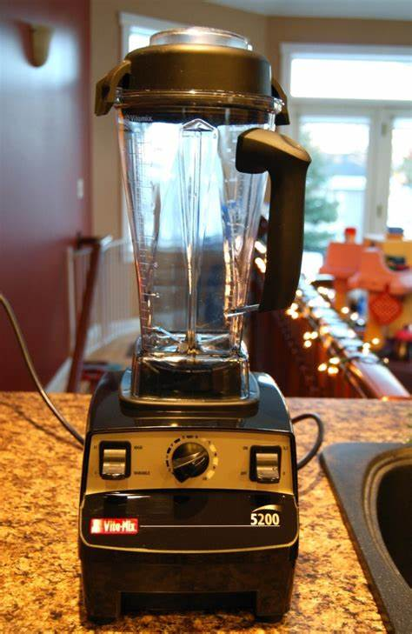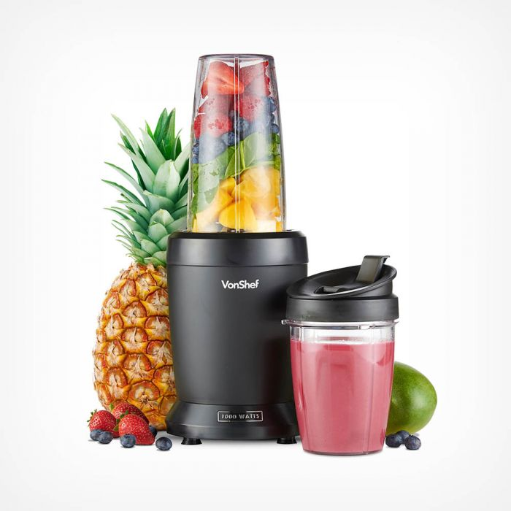
Syringes:
Use a 60ml syringe to administer blended diets.

Extension sets:
Use bolus giving sets or right angled extension sets to administer feed.

Other: You may find the following equipment useful -
Labels to date containers, cool bags to transport blended food, lidded containers for food storage.
How do I minimize the risk of infection?

When food is blended, there is an increased risk of food poisoning as germs can multiply much more easily. It is therefore important to:
- Wash hands thoroughly with soap and hot water before and during cooking and blending
- Wash all equipment and surfaces thoroughly (including blender) before use
- Blended food should be prepared as close to administration time as possible.
- Blended food should not remain at room temperature for longer than 2hours.
- Blended food may be stored on the top shelf of the fridge (below 5ºC) for up to 24hours.
- Blended food may be frozen (below-18ºC) and should not be kept for longer than 1 month. Food safety guidance on defrosting should be followed.
- Follow the use by date advice given by manufacturers.
Further information on food hygiene and how to store food safely can be found at the following websites or ask your dietitian.
www.nhs.uk
www.food.gov.uk

How do I prepare blended food?
Cook all ingredients as per pack/recipe instructions then blend until a thin, smooth consistency is achieved (use of a high powered blender should be considered to minimise risk of tube blockage and maximise nutritional content).

You may need to add more liquid to the blend to achieve a liquid consistency that can be easily plunged.
Where possible add liquids that increase the nutrition of the meal such as milk, cream or fruit juice. Avoid water as this may cause your food to separate and will dilute the nutritional value.

How do I transport and store the blended food?
Blended food can be stored in appropriate food containers. It is recommended that these are clearly labelled with the date food was made and what the food is (you may need to put your child’s name on the label if it is to be sent to school or other institutions.)
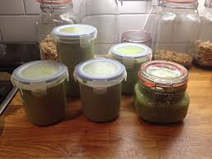
If you are going out, cool bags (with a cool pack) are ideal to store the containers of blended food to keep them at an appropriate temperature for short periods of time.

How do I give blended food down the gastrostomy?
- Use a 60ml syringe to draw up a small amount of the blended food to ensure it is the right consistency - if food is difficult to go through the syringe, it may be too thick or lumpy in which case add more fluid and try blending it again.
- Attach 60ml syringe to the gastrostomy (or extension set if being used). Pour the blended food into the syringe
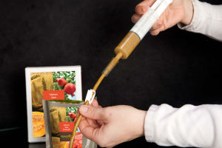

- If blended food does not flow through by gravity you may need to apply small gentle pressure on syringe plunger – making sure that the blended food will go gradually through the syringe.
- Blended food should be given at a slow and steady rate 5-20 ml at a time, pausing in between.
- Repeat steps 2 & 3 until the desired amount of blended diet has been given. (See Dietitian plan for amounts recommended).
- If necessary, give a break and small flush of water between syringes of liquidised food to clear the tube and prevent blockage (e.g. 1-2 x 60ml syringes – then break)

How do I change over to blended food?
Your Dietitian will advise you on how to do this. (See Dietitian plan)
This is likely to be a gradual change over and they might advice you to introduce small amounts of blended diet with prescribed feed during the first few days
Your Dietitian will also guide you on the volume and number of blends you should be giving per day.

What should I blend?
Some families may prefer to blend meal by meal, other families may want to cook a big batch and freeze. This is entirely up to you. Your Dietitian can provide you with some recipes to get you started.
It is important to provide your child with a balanced diet. Your Dietitian will give you advice on how to achieve this. For more information please visit:
https://www.nhs.uk/live-well/eat-well/the-eatwell-guide/
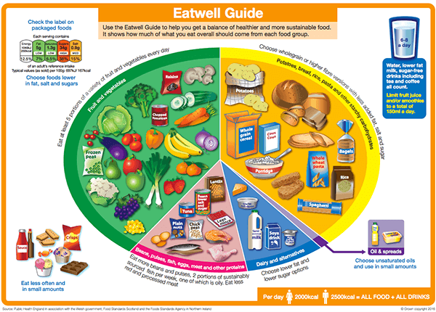

Other information
- The duration of the feed should take the same amount of time a meal would take to eat, however it may be longer depending on your child tolerance. It is important to watch your child during feeding to ensure they are comfortable.
- Your Dietitian will discuss and supply a feeding plan to ensure adequate diet and fluids.
- We recommend a vitamin D supplement (10 micrograms) for all children over 1 year on blended diet. Liaise with your Dietitian for further advice.
- Your Dietitian will need to assess nutritional adequacy of the blended diet regularly. Please complete a detailed food diary and give to your Dietitian when requested.
- If there is a concern with nutritional intake, blood tests may be required to identify any nutritional deficiencies and if treatment is needed.
- If you wish your child to have blended diet via gastrostomy at other care settings i.e. respite carer, school etc. please discuss this with your Dietitian and Children’s Community nurse. A meeting will need to be arranged with your child’s school to discuss the administration of blended diet there.

Tips and Recipes

The next few pages provide some recipes to help you get started. Once you feel confident, you will be able to create your own recipes using your normal meals. It is important to inform your dietitian of recipes you are using regularly so that they can check all nutritional requirements are being met.

Tips
Easy to blend foods:
Fruit: Bananas, ripened fruit: pears, peaches, mango, stewed and tinned and frozen fruit.
Vegetables: Well cooked vegetables, avocado.
Starchy Carbohydrates: Porridge/Weetabix, well cooked potatoes, cooked pasta, tinned pasta, Semolina/Couscous/quinoa (add hot water and allow to cool).
Protein: cooked fish (no bones or skin) cooked tender meats: chicken, lamb, lean minced meats (grissle does not blend and may need to be sieved). Cooked eggs, baked beans, tofu, quorn.
Difficult to blend foods:
Savoury rice (rice pudding is usually alright).
Bread or toast.
Biscuits.
Muesli.
Sweetcorn.
Raw vegetables.
Seeded fruits (e.g. raspberries/blackberries).
Nuts and seeds.
Foods with husks such as peas and beans may need to be sieved.

High Energy Ingredients:
Adding these to your recipes will increase the energy content of your blends:
Honey (over 1 year olds), oil, butter, cheese, cream cheese, salad cream, avocados, nut butter.
Use high energy liquids such as full fat milk, fresh fruit juice, cream. You can also use your child’s prescribed milk with blended foods. Try to avoid adding water.
Ready to use foods:
Drinking yoghurts
Stage 1 baby food pouches/jars
Drinking cereal e.g. ready to drink Weetabix
Milkshakes
Smoothies

Meal ideas

Breakfast Each Meal provides approx 175kcal and 6g protein.
- 150g porridge made with whole milk.
- 1 Weetabix made with 160ml whole milk.
- 120g porridge made with whole milk and 100g tinned peaches.
- 100g porridge made with whole milk and 1 small banana.
- 1 Weetabix, 1 medium banana and 200ml full fat milk.

Meal Ideas (250kcal approx.)
- 25g beef stewed, 60g carrots, 100g mashed potato, 60g cauliflower and 9g butter. Stage 1 food pouch.
- 25g pork casserole, 100g mashed potato, 60g carrots, 60g broccoli, 10g butter, 65ml apple juice and 10g honey.
- 38g salmon steamed, 100g mashed potato, 60g broccoli, 60g cauliflower, 6g butter and 20g honey.
- 30g Chicken breast, 100g mashed potato with butter, 60g carrots, 60g broccoli, 115ml apple juice and 40ml single cream.

Recipes:

Fish Pie
Makes 4 x 200ml blends.
Per 200ml blend: 200kcal, 6g protein
Ingredients:
125g skinned and boned white fish
150 ml full fat milk
40 g butter
15 g flour
250g potatoes-peeled
75g peas/ other vegetable

Preparation:
Pre-heat the oven to 200C/180 F/Gas mark 6
Cooking time 20 minutes
- Peel and chop the potatoes. Boil in water until cooked. Mash the potatoes, add 12g butter and 50 ml milk. Mix well.
- Sauce: Add 12g of butter and 15g flour to a pan. Cook for 1 minute, add 100ml full fat milk gradually mixing it with a whisk/wooden spoon. Bring to the boil and simmer until it thickens.
- Add the fish to an oven proof dish add the egg, peas and sauce. Cover with the mashed potatoes
- Cook it in the oven for 20-30 minutes.
- Once cooked, allow to cool down a bit and blend as per advised provided.

Shepherd’s Pie

Makes 10 x 200ml blends

200ml blend: 230kcal 7g protein

Ingredients:
- 1 tablespoon olive oil
- 150g minced meat
- 150ml beef stock
- 750g peeled potatoes
- 50g butter
- 2 tablespoon milk
- 150g carrots
- 1/2 tin tomatoes

Preparation:
- Pre-heat the oven 200C/Gas mark 6
- Fry the minced meat in a large frying pan with olive oil. Cook until brown.
- Add the flour to the meat and stir.
- Add the tin of tomatoes and chopped carrots.
- Add the stock and bring to the boil. Simmer 45 minutes.
- Boiled the potatoes. Mash and add 50g butter and milk.
- Add the mince mixture to an oven proof dish and cover with the mash.

Recommendations for storage, reheating and defrosting of blended diet
(NHS choices):
Some foods need to be kept in the fridge to help stop bacteria growing. These include foods with a "use-by" date, cooked foods and ready-to-eat foods, such as desserts and cooked meats.
Here's how to prevent bacteria from growing:
- Keep your fridge temperature at 5C or below. Most fridges are warmer than you think.
- When preparing food, keep it out of the fridge for the shortest time possible.
- If you're having a buffet, keep the food refrigerated until you're ready to serve it.
- Cool down leftovers as quickly as possible (ideally within 90 minutes), store them in the fridge and eat them within two days.
- Store eggs in their box in the fridge.
- Never put open cans in the fridge, as the metal may transfer to the can's contents – place the contents in a storage container or covered bowl instead.

'Use-by' dates

No food lasts forever, however well it is stored. Most pre-packed foods carry either a "use-by" or a "best before" date.
- "Use-by" dates appear on foods that go off quite quickly. It can be dangerous to eat foods past this date.
- "Best before" dates are for foods with a longer life. They show how long the food will be at its best quality.

Storing meat
It's particularly important to store meat safely in the fridge to stop bacteria from spreading and avoid food poisoning.
- Store raw meat and poultry in clean, sealed containers on the bottom shelf of the fridge, so they can't touch or drip onto other food.
- Follow any storage instructions on the label and don't eat meat after its use-by date.
- Keep cooked meat separate from raw meat.

Freezing and defrosting
It's safe to freeze meat and fish as long as you:
- freeze it before the use-by date
- defrost meat and fish thoroughly before cooking – lots of liquid will come out as meat thaws, so stand it in a bowl to stop bacteria in the juice spreading to other things
- defrost meat and fish in a microwave if you intend to cook it straight away, or put it in the fridge to thaw so it doesn't get too warm
- cook food until it's piping hot all the way through
- Make sure the meat is properly wrapped in the freezer or it might get freezer burn, which will make it tough and inedible

Re-freezing
Never re-freeze raw meat (including poultry) or fish that has been defrosted. It is possible to re-freeze cooked meat once, as long as it has been cooled before going into the freezer. If in doubt, don't re-freeze.
Frozen raw foods can be defrosted once and stored in the fridge for up to two days before they need to be cooked or thrown away. To reduce wastage, divide the meal into portions before freezing and then just defrost what you need.
Cooked food that has been frozen and removed from the freezer must be reheated and eaten immediately once fully defrosted. When defrosted, food should be reheated only once, because the more times you cool and reheat food, the higher the risk of food poisoning. Bacteria can grow and multiply when food is cooled too slowly, and might survive if food isn't reheated properly.
When reheating food, make sure it is heated until it reaches a temperature of 70C for two minutes, so that it is steaming hot throughout.
Foods stored in the freezer, such as ice cream and frozen desserts, should not be returned to the freezer once they have started to thaw. Only take out of the freezer what you intend to use for that meal.

Cooking
Cooking food at the right temperature will ensure that any harmful bacteria are killed. Check that food is piping hot throughout before you eat it.
The foods below need to be cooked thoroughly before eating:
- poultry
- pork
- offal, including liver
- burgers
- sausages
- rolled joints of meat
- kebabs
When cooking burgers, sausages, chicken and pork, cut into the middle to check that the meat is no longer pink, the juices run clear and it's piping hot (steam is coming out).
When cooking a whole chicken or other bird, pierce the thickest part of the leg (between the drumstick and the thigh) to check there is no pink meat and that the juices are no longer pink or red.
Pork joints and rolled joints shouldn't be eaten pink or rare. To check when these types of joint are ready to eat, put a skewer into the centre of the meat and check that there is no pink meat and the juices run clear.
When cooking burgers, sausages, chicken and pork, cut into the middle to check that the meat is no longer pink, the juices run clear and it's piping hot (steam is coming out)...
If you've cooked food that you're not going to eat immediately, cool it at room temperature (ideally within 90 minutes) and store it in the fridge. Putting hot food in the fridge means it doesn't cool evenly, which can cause food poisoning. Find out more about storing leftovers, please visit:
https://www.nhs.uk/live-well/eat-well/how-to-store-food-and-leftovers/

Washing fruit and vegetables
It's advisable to wash fruit and vegetables under cold running water before you eat them. This helps to remove visible dirt and germs that may be on the surface.
Peeling or cooking fruit and vegetables can also remove these germs.
Never use washing-up liquid or other household cleaning products, as they might not be safe for human consumption and you may accidentally leave some of the product on the food.

Cleaning up
Wash all worktops and chopping boards before and after cooking, as they can be a source of cross-contamination.
Damp sponges and cloths are the perfect place for bacteria to breed. Studies have shown the kitchen sponge to have the highest number of germs in the home. Wash and replace kitchen cloths, sponges and tea towels frequently.

Information produced by: Northumbria Healthcare NHS Foundation Trust Dietitians

Date: March 2022
Review Date: March 2025

