Pupil premium strategy statement

This statement details Northern Counties School’s use of pupil premium funding to help improve the attainment of our disadvantaged pupils.

It outlines our pupil premium strategy, how we intend to spend the funding this academic year and the outcomes for disadvantaged pupils last academic year.

School Overview
Detail | Data
School name | Northern Counties School
Number of pupils in school | 88
Proportion (%) of pupil premium eligible pupils | 47.7%
Academic year/years that our current pupil premium strategy plan covers | 2025-28
Date this statement was published. | December 2025
The date on which it will be reviewed | July 2028 (and annually interim)
Statement authorised by | Martin Lonergan  Headteacher
Pupil premium lead | Simon Adams  Abi Cowie  Helen Blakelock
Governor / Trustee lead | Jeff Lough
Funding overview
Detail | Amount
Pupil premium funding allocation this academic year | £45,985
Recovery premium funding allocation this academic year | 0
Pupil premium funding carried forward from previous years (enter £0 if not applicable) | £0
Total budget for this academic year | £45,985

Part A: Pupil premium strategy plan

Statement of intent
We aim to use pupil premium funding to help us achieve and sustain positive outcomes for our most disadvantaged pupils. Whilst socio-economic disadvantage is not always the primary challenge our pupils face, we have identified some key areas that will support our pupils to acquire new knowledge and skills and to be able to transfer and apply these in their daily lives. These include:
- Communication skills: receptive, expressive, and social communication skills
- Wellbeing: happiness and emotional regulation
- Independence skills: functionality in the activities of daily living
- Parental engagement: support parents/carers to develop skills and access resources and training to help pupils achieve their EHCP outcomes.

Pupil premium funding will be used in different ways by different cohorts. Central to our approach is high-quality teaching and therapy focused on the needs of our most disadvantaged pupils but includes some strategies that will benefit our pupils. All our pupils have Education, Health, and Care Plans, and many have complex and co-morbid needs, so we will plan to help our non-disadvantaged pupils alongside their disadvantaged peers. Given the effective use of pupil premium funding in 2022-2025 that led to disadvantaged pupils making equivalent rates of progress as their non-disadvantaged peers, we would seek to maintain the tangible benefits of some of these strategies through the next three academic years.
We will continue to support disadvantaged pupils to promote their independence and social skills through targeted therapy and positive risk-taking.
Pupil wellbeing continues to be a focus for the school, especially in light of the pressures on mental health services such as CYPS and CAMHS. If students are settled and ready to learn, families can engage and support the development of a waking-hours curriculum.
Our strategy will be driven by the needs and strengths of the young people as described within their EHCPs. Pupil outcomes are based on detailed observation and assessments in conjunction with the summative assessment models in place within the school. At the heart of our approach is the provision of targeted actions to develop the knowledge, skills, understanding and ‘readiness for learning’ that prepare our young people for adulthood.

Challenges
This details the key challenges to achievement that we have identified among our disadvantaged pupils.
Challenge number | Detail of challenge
1 | Communication skills: receptive, expressive, and social communication skills  Our assessments, observations and discussions with pupils and their families/carers show significant communication difficulties.
2 | Wellbeing: happiness and emotional regulation  Our assessment, observations and discussions with pupils and their families/carers identify that our pupils have significant emotional difficulties that impact on their wellbeing and ability to make academic progress. The numbers of pupils requiring support with mental health and wellbeing, especially at an Early Help level is growing, and the lengthy waiting lists for support from NHS services often requires school to bridge this with single agency support.
3 | Independence skills: functionality in the activities of daily living  Our assessments, observations and discussions with pupils and their families/carers demonstrate that disadvantaged pupils have fewer opportunities to develop functionality in most aspects of daily living and require targeted support to achieve this. They need more support than their non-disadvantaged peers to gain independence skills.
4 | Parental engagement: support parents/carers to develop skills and access resources to help pupils achieve their EHCP outcomes. Our conversations with families/carers indicate that they need and welcome opportunities to support each other, develop an understanding about their children's diagnoses, and develop communication skills that enable them to communicate effectively with their children and help them achieve their full potential. Parents need to feel engaged with the school and be able to rely on the school for coordinated emotional, well-being, moral and signposted support.

Intended outcomes.
This explains the outcomes we aim for by the end of our current strategy plan and how we will measure whether they have been achieved.
 | Intended outcome | Success criteria - at the end of our 3-year strategy - July 2028
1 | Communication skills  Improve language comprehension and expression for disadvantaged pupils so that they can express themselves more effectively. | 80% of pupils achieve their EHCP communication outcomes
2 | Wellbeing  Pupils are well-regulated and can attend to learning tasks for increased periods.  Staff feel supported in school. | 90% of pupils achieve their iASEND PSED target (July 2028)  Overall staff feedback through Hive increases to 6.5.  Parent View responses reach the following rates:  - Concerns are dealt with correctly 90%  - School supports my child’s personal development 90%  - I would recommend this school 93%
3 | Independence skills  Pupils develop skills to improve their independence in the activities of daily living. | 80% of pupils achieve their EHCP independence outcomes.
4 | Parental engagement  Parents/carers feel skilled in creating supportive routines, environments, and communication with their children. | 50% of parents/carers engage with pupil-centred sessions (workshops, training, or stay-and-play type activities), parent consultations and coffee mornings. Uptake and engagement through Earwig are increased to 50% or greater.

Activity in this academic year
This details how we intend to spend our pupil premium (and recovery premium funding) this academic year to address the abovementioned challenges.

Teaching (for example, CPD, recruitment and retention)
Budgeted cost: £29,539 per annum
Activity | Evidence that supports this approach | Challenge number(s) addressed
Employ a part-time outdoor learning tutor. | Forest School is a learning philosophy focused on child-led learning in a natural environment. It is a long-term process led by trained Forest School leaders who facilitate supported risk as well as facilitating holistic learning.  https://www.cambridgeforestschools.co.uk/schools/forest-school-and-outdoor-learning-research/  https://www.lboro.ac.uk/media-centre/press-releases/2017/october/study-reveals-forest-school-benefits  The Forest School impact on children: reviewing two decades of research.https://www.tandfonline.com/doi/abs/10.1080/03004279.2021.1889013 | 1, 2, 3

Targeted academic support (for example, tutoring, one-to-one support, and structured interventions)
Budgeted cost: £
Activity | Evidence that supports this approach | Challenge number(s) addressed

More comprehensive strategies (for example, related to attendance, behaviour, and wellbeing)
Budgeted cost: £16,446 (contribution) per annum
Activity | Evidence that supports this approach | Challenge number(s) addressed
Maintenance of a Wellbeing Coordinator role to support pupils, families, and staff | The House of Commons Education and Health Committee published their report ‘Children and young people’s Health - the Role of education’ in May 2017, and the DfE produced ‘Mental Health and behaviour in Schools’ in November 2018. Both reports highlight the importance of promoting positive mental health outcomes for students and the schools’ role in this.  Mental health and behaviour in schools  https://publications.parliament.uk/pa/cm201617/cmselect/cmhealth/849/849.pdf  Furthermore, the DfE launched guidance around promoting and supporting mental health and wellbeing in schools and colleges in June 2021 (and updated in November 2022). Taking a coordinated and evidence-informed approach to mental health in schools and colleges leads to improved pupil and student wellbeing, which, in turn, can improve learning.  https://www.gov.uk/guidance/mental-health-and-wellbeing-support-in-schools-and-colleges | 2, 4
Parent/carer engagement through support for individuals and groups and workshops. | The Education Endowment Foundation produced their report, ‘How can schools support parents’ engagement in their children’s learning? Evidence from research and practice.  https://educationendowmentfoundation.org.uk/education-evidence/evidence-reviews/parental-engagement | 4

Total budgeted cost: £ 45,985

Part B: Review of outcomes in the previous academic year

Pupil premium strategy outcomes
This details our pupil premium activity's impact on pupils in the 2024 to 2025 academic year.
iASEND – 90% of learners have achieved or exceeded their targets. Five learners did no achieve or exceed their targets, two of these had very low attendance/engagement in the curriculum. The remaining three all achieved the iASEND set target, but not the challenging extended target set by school. By subject, we exceeded anticipated progress in all areas.

 | Intended outcome | Success criteria - at the end of our 3-year strategy - July 2025 | Progress 2024-25 | Evidence
1 | Communication skills  Improve language comprehension and expression for disadvantaged pupils so that they can express themselves more effectively. | 80% of pupils achieve their EHCP communication outcomes | On track | IEP progress data
2 | Wellbeing  Pupils are well-regulated and can attend to learning tasks for increased periods.  Staff feel supported in school. | 90% of pupils achieve their iASEND PSED target (July 2025)  24-month staff turnover reduces by 50%  Overall staff feedback through Hive increases from 6.5 to 7.5.  Parent View responses reach the following rates:  - Concerns are dealt with correctly 90% (from (76%)  - School supports my child’s personal development 90% (from 78%)  - I would recommend this school 93% (from 83%) | Achieved  Achieved  Not achieved  Ongoing | iASEND. 90% of learners achieve or exceed targets
3 | Independence skills  Pupils develop skills to improve their independence in the activities of daily living. | 80% of pupils achieve their EHCP independence outcomes. | On track | IEP progress data
4 | Parental engagement  Parents/carers feel skilled in creating supportive routines, environments, and communication with their children. | 50% of parents/carers engage with pupil-centred sessions (workshops, training, or stay-and-play type activities), parent consultations and coffee mornings. Uptake and engagement through Marvellous Me and Earwig are increased to 50% or greater. | Achieved – engagement in parent and family events is good, and over 50% | A small number of parents engage regularly and frequently with support sessions and staff.

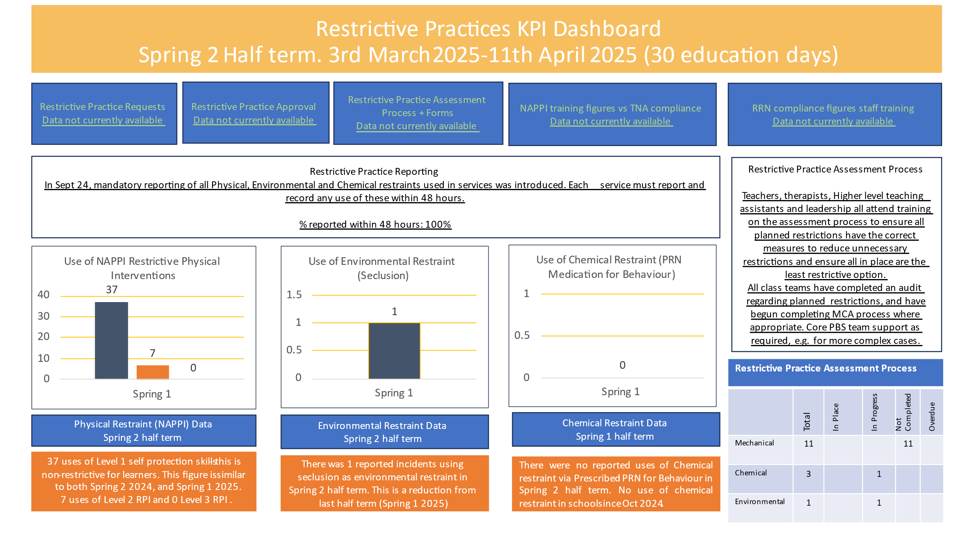

Externally provided programmes.
Please include the names of any non-DfE programmes you purchased in the previous academic year. This will help the Department for Education identify popular ones in England.
Programme | Provider
Phonics for Pupils with SEN | Ann Sullivan

